

**UNIVERSITY OF HERTFORDSHIRE**

Department of Computer Science

MSc Cyber Security with Advanced Research

7COM1070 – Cyber Security Masters Project

September 2022

**Penetration Testing the Cloud Environment**

**Name:** Constantin-Alexandru Apetrei

**Student ID:** 14168072

**Supervisor:** Seyedali Pourmoafi

# Declaration

This report is submitted in partial fulfilment of the requirement for the degree of **Master of Science** in **Cyber Security** at the **University of Hertfordshire (UH)**.

It is my own work except where indicated in the report.

I did not use any human participants in my MSc Project.

I hereby give permission for the report to be made available on the university website provided the source is acknowledged.

**Signature:** Constantin-Alexandru Apetrei

**Date:** 03-09-2021

# Acknowledgements

I would like to take this opportunity to express my gratitude towards my supervisor **Mr. Seyedali Pourmoafi** for understanding my situation and encouraging me to finish the project.

Secondly, I want to thank my family and my fiancée for their unconditional support because I would never be here without them. There are a lot of things that might change in your life or will change you as a person, but one thing is for sure, **family is everything**.

In the end I would like to say a big thank you to everyone at University of Hertfordshire. I have joined this university on a two-year course: Cyber Security with Placement Year but due to the pandemic I was not able to find the right placement and I continued with the Cyber Security Advanced Research route. It was a very difficult year for me because I did not think my second year will be how it was and I also had some academic and health issues which I had to overcome in order to finish my degree.

Thank you, University of Hertfordshire.

# Abstract

Cloud computing provides one of the easiest, cost-effective, and flexible services and solutions to both unprofessional users and businesses. A lot of small and large business are starting to transfer their system structures to the cloud because of the large opportunities the cloud services provide. While the need for the cloud grows every day, the possible security issues are a big priority for organisations and researchers. The simplicity of using the cloud is not a really positive thing because it can lead to big security issues and these computing cloud security flaws need to be examined more in-depth. In order to discover the security issues inside an organisation, penetration testing is expected.

The security is the most important aspect in the cloud environment because every part of the systems communicates with each other using the internet and any small security error could affect a crucial part of the system structure. This is the main reason why the cloud is working on its security day by day in order to make it safer by investigating all the security breaches or errors and different methods such as penetration testing or vulnerability assessments are used.

Penetration testing is very different compared to hacking, cloud computing penetration testing could be restrictive and challenging because there will be a sequence of complex phases which needs to be done in order to produce a penetration test report. Penetration testing is known as the best practice of testing how strong a computer network or system is, in order to discover any type of weaknesses which can be used by hackers to break the system. So, the research is based on how efficiently and important a penetration test can be for the cloud environment and why these tests are necessary. This type of test is very important these days because it can keep the security team prepared to act in case the system or the network is attacked and allows them to get an idea of any issue that can be found during an attack. This project will involve the use of some techniques and tools in order to plan, execute and evaluate a penetration test of the AWS permitted cloud services.

.

Contents

Declaration 2

Acknowledgements 3

Abstract 4

Chapter 1 – Introduction 6

1.1 Background 6

1.2 Project Specification 6

1.3 Research Question and Motivation 8

1.4 Aims and Objectives 8

1.5 Project Plan 9

Chapter 2 – Literature Review 10

2.1 Cloud Computing 10

2.1.1 Why Clouds Matter 11

2.1.2 Types of Cloud Computing and Service Models 11

2.1.3 Cloud Service Providers 13

2.2 Penetration Testing 14

2.3 Overview of Penetration Testing the Cloud Environment 16

2.4 Amazon Web Service 16

2.4.1 AWS Services 17

2.4.2 Elastic Compute Cloud (EC2) 17

2.4.3 Amazon S3 17

2.4.4 Amazon S3 17

2.4.5 Amazon RDS 18

2.5 AWS Penetration Tools 18

2.5.1 Kali Linux 18

2.5.2 NMAP 18

2.5.3 Metasploit 18

2.5.4 PACU 19

2.5.5 PuTTY 19

Chapter 3 – Methodology 20

3.1 Research Methodology 20

3.2 Cloud Pen Testing Methodology 22

3.2.1 Cloud Pen Testing Plan 23

3.2.2 Cloud Pen Testing Execution 24

Chapter 4 – Results and Discussions 29

4.1 Introduction 29

4.2 Foot Printing / Reconnaissance 29

4.3 Scanning 30

4.3.1 Port Scanning 30

4.3.2 Vulnerability Scanning 31

4.4 Exploitation 31

4.5 Post Exploitation 31

4.6 Discussion 31

Chapter 5 – Conclusion 32

Chapter 6 – Bibliography 33

Chapter 7 – Appendix 35

# Chapter 1 – Introduction

## 1.1 Background

Cloud Computing is the source of computing assets as a service which are managed and owned by a cloud provider instead of an end-user. Using a cloud environment, businesses are able to optimise costs and also expand what they have to offer without the need of acquiring or handling all the software and hardware. This means that they do not have to worry about any main-frame, hard drive or where any piece of software and hardware is allocated. The services offered by the cloud had many benefits and it is the first choice for both unprofessional users and business. With the fast-growing availability of cloud-based services, applications, machines and storages, typical users and business have access to a variety of on-demand computing assets as well as internet-accessed services.

The impact of cloud computing industry is huge and there is a remarkable increase in usage but along with this, security concerns also arise. Even if the cloud computing technology is adopted all over the world, there is not too much information about its security issues and also about the cloud attacks. The diversification of cloud models has security risks where various attacks are now targeting the cloud infrastructure. The research part of cloud computing security issues is crucial and requires some methods such as penetration testing or vulnerability assessment to be used. In this project a penetration test of the cloud will be executed and the results will be evaluated to see if there are any security issues found. From a security point of view, it is essential to understand the security routes which could exploit potential vulnerabilities of in the cloud infrastructure. Using a penetration test is vital for any system as its findings could reveal various types of system misconfiguration, weaknesses, or any other security problem.

A cloud penetration test is an approved and simulated cyber-attack against a system which is hosted on a cloud provider such as Amazon Web Services (AWS) and Microsoft’s Azure. A big benefit of performing such a test is to get a better knowledge of the attack surface that the particular system is exposed to. Cloud penetration testing involves a mixture of internal and external pen tests procedures in order to assess the external posture of the selected organisation.

## 1.2 Project Specification

In this project a penetration test of the cloud will be executed and the results will be evaluated to see if there are any security issues found. The main goal of the pen test is to see how strong the specific system is; so that its security posture can be completely evaluated. The test is also known as one of the best ways to test a computer system, network, or any hosted application to discover potential weaknesses that hackers could take advantage of it. The cloud penetration testing involves a mixture of internal and external penetration testing procedures in order to examine the exterior posture of the business. An example of exposures determined by this kind of active testing includes the vulnerable S3 buckets or storage spots, servers with weak way-out controls and running ports open to the internet.

The cloud approval and policy information are needed in order to perform a penetration test because of the cloud providers limitations but most of the cloud providers allow anyone to carry out a penetration test if their policy is strictly followed. For example, two of the most common cloud providers, Microsoft Azure and AWS does no longer require any kind of authorisation in order to perform a pen test but there is a list of what you can and what you cannot test. Anyway, the penetration test plan should include all the exceptions and permissions of the cloud provider the test will be taken on. After the test will be performed, the results will be evaluated in order to see if there is any security issue with the specific cloud system. To have a successful project, as there are a lot of things involved in a penetration test process, the testers have to think and act as a hacker will. This is why such a test is not an easy task and a really developed plan is needed in order to have a successful pen test. One of the best ways to approach this will be to an attack and defence setup which is capable of testing the mechanical defence system while having the possibility of finding some security weaknesses.

The first steps are to make sure that all the policy permitted and prohibited services are followed to prevent any kind of risk of the penetration testing becoming illegal. For example: if there is an application which runs on a public cloud and someone decides to attack it then it will look like an DDoS attack and the cloud provider can shut down your account as the security team will see it as a real attack. The second step is to produce a specific penetration testing plan which is needed to execute such a test and this plan will include some of the following items: data access, applications, virtualisation, automation, data access, compliance, approach, and network access; this plan will be strictly followed. Selecting the right tools is also very important because these tools are part of the penetration testing process and they are used to simulate a real attack on the cloud. Another important aspect is how and from where the test is performed because for example, many penetration testers are working in teams as there are some very complex systems which requires multiple kind of methods in attempting to break it. If it is performed in a house, it means that some security issues might not be found as there will be very hard for one person to execute multiple techniques over a short period of time. This is one of the main risks of this project because it will be mostly done in-house. So, the test will be executed based on the cloud provider’ policy which is the Amazon Web Services (AWS) and the aim is to find any security issues if there are any. After the test part will be done, the final stage is to analyse all the results in order to produce and pen test report which will include all the findings, if there are any system security vulnerabilities and if there is any, they will have to be reported to the cloud provider to make sure they are aware of them, so they can be fixed in time to prevent a real attack. The penetration testing is one of the few options to prove that the selected cloud environment data and applications are protected enough in order to allow the highest amount of users to use it with the lowest amount of risk.

The main aim of this thesis is to perform a penetration test of the Amazon Web Service which is one of the most used cloud computing platforms in the world. According to the global market share of Q1 2021, AWS is the leading cloud infrastructure service provider. This market dominance of Amazon Web Services over the years is the main reason why this cloud provider was chosen to be the foundation of this research thesis.

## 1.3 Research Question and Motivation

The most important part of the project is to have a clear research question because it is the first vital part of the project. The research question is based on the project topic which is the cloud environment security and penetration testing. The project aims to provide enough evidence in order to answer a research question and to conduct a practical investigation where a pen test of a cloud provider will take place. The main question related to this thesis is “What is the importance of performing penetration testing of the Cloud Environment?”. The motivation of this RQ is to identify and investigate exposures which can be manipulated by cyber criminals in order to attempt to gain access and steal cloud environment resource. The research will take part using the research question as the main topic and other research papers will be investigated. These papers will also strongly be discussed in order to determine the importance of a penetration test on the cloud environment and why there is a need of such a test to improve the systems’ security or discover weaknesses within the system. Also, the work on the project will attempt to answer a couple of other questions such as “How strong the selected cloud provider security is?” or “Why there is a need of using a penetration testing to find cloud security issues?”. These questions are also part of the thesis because the main objective here is to establish the need of a penetration test in these environments and why are they important. Having a research question on the project is very important because it actually defines what kind of research the writer will be looking for and it connects the objectives paper or the study will address.

## 1.4 Aims and Objectives

As the project title suggests, the main focus of this paper is to perform a penetration testing in the cloud and to evaluate the finding in order to answer the research matter. This kind of test is really important in an organisation because it can help to discover any potential security issues that can be used by hackers to breach and steal the data. There is need for a very complex plan to be able to perform a successful penetration test and it needs to be used in accordance with the cloud provider’s security policy because some providers have a list of what you can and what you cannot attack during a test. One of the best options is to have an attack and defence set-up ready to be ready to test the cloud automated defence system in order to discover potential security weaknesses.

There is a huge difference between a normal system pen test and the cloud environment pen test; the most important one is that the cloud security policy is very strict and this important factor can make such a test very complicated as there is no private cloud. There is a huge difference between a normal system pen test and the cloud environment pen test; the most important one is that the cloud security policy is very strict and this important factor can make such a test very complicated as there is no private cloud. The aim is clear that the penetration test performed should be 100% legal and all the factors, such us cloud permissions or prohibited activities, are taken in consideration. The second thing is to execute such a test in order to get the results and analyse them to be able to generate a full report of all the findings. If there are any system security weaknesses found, they will be added to the final report of the test and reported to the cloud provider in order to make they aware of the findings so that they can be fixed before a real attack will take place.

The main objective of the project is to use all the knowledge gained from the penetration testing module of the cyber security master course and to also learn new factors and techniques of the penetration testing area. This project will help me to get a more precise overview about what a pen test really is and why is it important for some organisations. So, the main goal is to produce a successful plan for the project, a penetration test and to be able to answer the question related to the importance of a penetration test in the cloud environment and why do all the systems need to perform such a test in order to improve their security issues if there are any. The projects most important objective is to discover if the penetration test of the cloud environment is effectively enough to keep the system security and data to not be compromised.

## 1.5 Project Plan

The project plan is one of the most important parts of producing the right piece of work because all the stages and tasks needs to be known so the project will be a successful one and also be finished in time to meet the deadlines. The following table include details of all the tasks performed as part of the project and the dates that the tasks have been achieved.

|  |  |  |  |
| --- | --- | --- | --- |
| **Task No.** | **Task**  **Name** | **Task**  **Details** | **Deadline Day** |
| **1** | Project Proposal | Identify a subject for the final year project. | 20/04/2021 |
| **2** | Interim Progress Report | Search and provide information about the final year project subject. | 7/05/2021 |
| **3** | Project Specification | Set the project objectives and aims. | 20/06/2021 |
| **4** | Systematic Literature Search | Information related to the project subject and the tools needed for it. | 04/07/2021 |
| **5** | Methodology | Identify the research and cloud pen test methodologies. | 30/07/2021 |
| **6** | Results and Discussions | Check if the results outcome and discuss it + the subject. | 20/08/2021 |
| **7** | Final Project Report | Verify all the thesis aspects, word count, structure, bibliography, Appendix, font, size, etc. | 31/08/2021 |
| **8** | FPR Submission | Finish project thesis, verify if the are any parts missing. | 03/09/2021 |
| **9** | Project Demonstration | Presentation part of the project. | 19-09-2021 |

# Chapter 2 – Literature Review

## 2.1 Cloud Computing

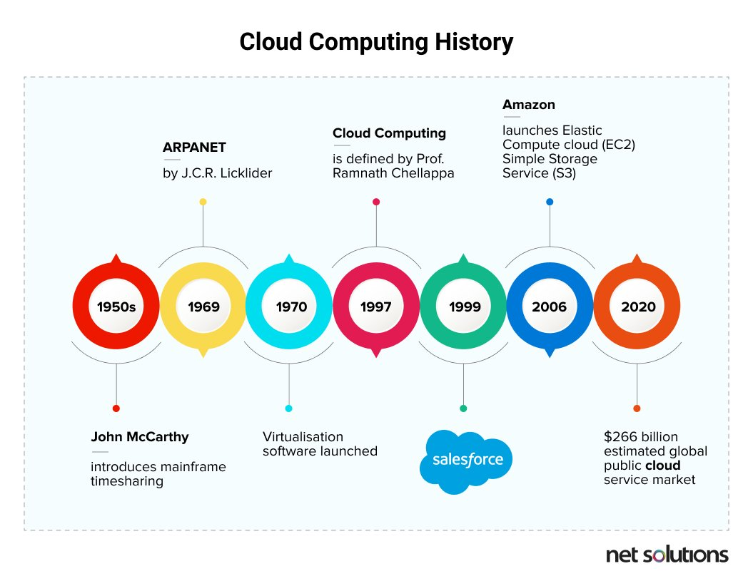Cloud computing is the use of internet linked servers to host virtual infrastructure and software controlled and accessed over the API or the web. It is a technology which allows different users to access software applications, test or develops new software, store data and also create virtual servers. In fact, it is a key component of every single system because of its benefits such as computation usability, capability, and efficiency over the Internet (Stergiou et al., 2018). It provides flexible, cost-effective, and easy services and solutions to both unprofessional users and companies. The term “cloud computing” has only been used for around a decade or so, but the actual history of cloud computing goes back further. This term is actually referring to any remote server – even a dedicated server or single virtual machine. If we start thinking about the cloud computing history or when was it invented, we need to go back 70 years. Between 1950 and 1960, computers were expensive, massive, and only possible for large organisations and corporations such as universities (Jain and Mahajan, 2017). This is also known as the age of the mainframe which is known to be a powerful computer with multiple user interfaces. Mainly “mainframe” was referred to the big cabinets which accommodated the main memory and the CPU (central processing unit). Every single mainframe was a multiuser computer very powerful by the standards of that time which the clients interacted with using a terminal During this period and more into the 1970s, the way clients interacted with computers changed a lot starting from punch cards, all the way through teletype printers, to basic screen terminals which are known today as the command line terminals.

**Figure 1. Cloud Computing History. (Source: net solutions)**

According to Blanchard (2014), the “mainframe clients” had no computing power and they were actually just simply interfaces for the mainframe computer which might be situated a long way from the operator and it was connected through a dedicated network. This model of computing is believed to be a precise predecessor of cloud computing because just as the cloud, the largest part of the process is executed on physical “servers” that the client does not immediately interact with and they are not placed on the local network. So, these early mainframes are actually identified as the beginning of the modern cloud environment. The first familiar structure-as-a-service platform became available all around the world in 2006. AWS (Amazon Web Services) and some other cloud providers started to change the way business manage, pay, and think about their infrastructure by offering a range of new services such as on-demand storage capacity. It is very well known that the digital industry is changing faster every day and that the technology is also growing and it is very hard to keep up to date with all the new concepts and developments. The cloud environment is not certainly a new development but it has only been a few recent years since the companies started to use it more than before. There are some important benefits of implementing the software, platform and infrastructure services offered by the cloud because it is very useful for those type of users that want to use the software for a short period of time.

### 2.1.1 Why Clouds Matter

One of the most common questions is associated with why is cloud computing important? According to Milles (2008), there are many benefits of cloud computing and one of it is group collaboration for both organisations and individuals because any users all around the world can work together on the same project, application, or document in real time. It is like a new world of collaborative computing and all of this is possible because of the new concept of cloud computing. For developers, cloud computing is offering an increased amount of storage space and also processing power which they can use to run the applications they develop. It also allows new techniques to gain access to information, manage and evaluate data. For IT departments, cloud computing offers more flexibility in computer power at lower costs. The end users take advantage of all the benefits listed above and even more because a single person which uses a web-based application is not actually attached to a single network, PC, or location. They can access their data any time they want and from anywhere around the world. Cloud computing does all these at reduced expenses because the way of sharing data is more efficient than the conventional network computing does. Another factor of proving that the cloud computing is very important is actuality about the hardware part which does not have to physically be in a data centre or a corporation's office.

### 2.1.2 Types of Cloud Computing and Service Models

According to National Institute of Standards and Technology (NIST), classification, Cloud Computing is a paradigm which provides a common and easy procedure in order to gain access and share computing resources. There are three types of cloud computing known as private, public and hybrid clouds. Businesses are actually able to decide to run their applications on any of the three models, also known as ‘deployment models’, depending on their individual needs. Private clouds are available over a private network or the internet and they also are the only available for the selected users, for example client’s employees (Garrison, Kim, and Wakefield, 2012).). The public cloud environment is a computing service provided by the third-party suppliers on public internet and it is accessible for anyone who chooses to utilise these services and they only need to pay for what they have used (Marston et al., 2011). Hybrid cloud is a mixture of private and public cloud, also known as multi-clouds, where the data and applications can be shared among the clouds and they can be 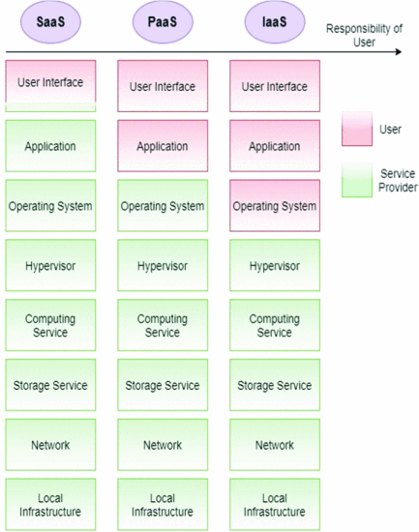operated independently (Garrison et al, 2012).

**Figure 2. Cloud Service Models (Marinescu, 2018)**

There are three types of cloud services identified as: Infrastructure as a Service (IaaS, Platform as a Service (PaaS) and Software as a Service (SaaS). Selecting the cloud service or cloud type is a unique decision. Figure 2 shows what the cloud service suppliers guarantee to their clients. As you can see, from right to the left, the flexibility, and capabilities of users drops while the easing of use increases.

* **Infrastructure as a Service** – At the same time the user has full control on most of the layers and has access to important computing resources, the user can actually use that infrastructure to manage software in the operating system stage. The majority of the maintenance obligation is held by the client which it means that every part of the system reinforcing problems must be done by the client until the infrastructure layer (NIST, 2011). It is perfect for small or medium size companies seeing for a cost-efficient IT solution in order to support enterprise growth. Marinescu (2018), states that the cloud service supplier is responsible for low-level tiers of systems as bare systems such as network systems, servers, and storage systems.
* **Platform as a Service – –** it is known as the medium model between the structure-as-a-service and software-as-a-service which is able to provide control to clients over the platform the same as developing an application using services, tools, and libraries while the consumers are not able to control the infrastructure of what they have built (Yurtseven and Bagriyanik, 2020). The PaaS solutions are ideal and accessible for business environments where numerous designers are working on a single project.
* **Software as a Services –** an application is offered to the client which is able to access it but cannot make any changes to it. At the same time clients who use this service cannot command the main composition of the cloud system. In order to provide a high usability, the service suppliers guarantee all the managemental components of the systems so that clients do not need to preserve the systems. According to Hussein and Khalid (2016), if there are software architectural problems than data associated security problems and data violations are possible in software-as-a-service.

### 2.1.3 Cloud Service Providers

A Cloud Service Provider is a third - party organisations offering a cloud-based infrastructure, storage, application, and storage services. Its main focus is based on different activities needed in order to provide a cloud service environment to their customers. These types of activities include monitoring and deploying the service by providing audit-data and support the infrastructure.

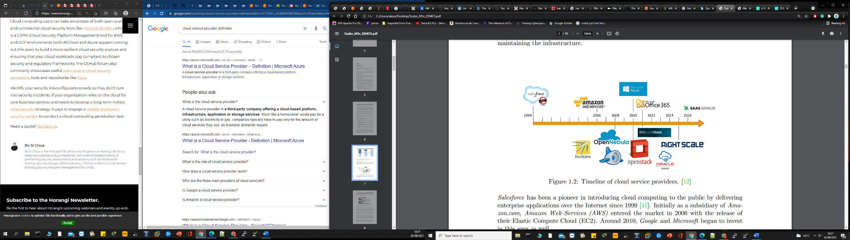In1999, an American cloud-based software company known as Salesforce was formed in order to introduce the cloud computing to the public by offering enterprise applications across Internet. (Krtuz and Vine, 2010). As shown in figure 3, in 2006 Amazon Web Services was the next company to enter the market around 2006 and they released EC2 (Elastic Compute Cloud). In 2010, two other big companies Microsoft and Google entered the market and started to invest in the same area. But even with this strong competitions, Amazon Web Services (AWS) continued to be the top leader of cloud computing market which provides market shares from 2017 where AWS dominated the market by 34% in the last 2 quarters of 2017 (Global Market Share, 2017). According to Brodkin (2016), Amazon Web Services registered around 1 million active business consumers in October 2016 This number continued to increase along with their profits.

**Figure 3. Cloud Providers’ timeline. (Google)**

## 2.2 Penetration Testing

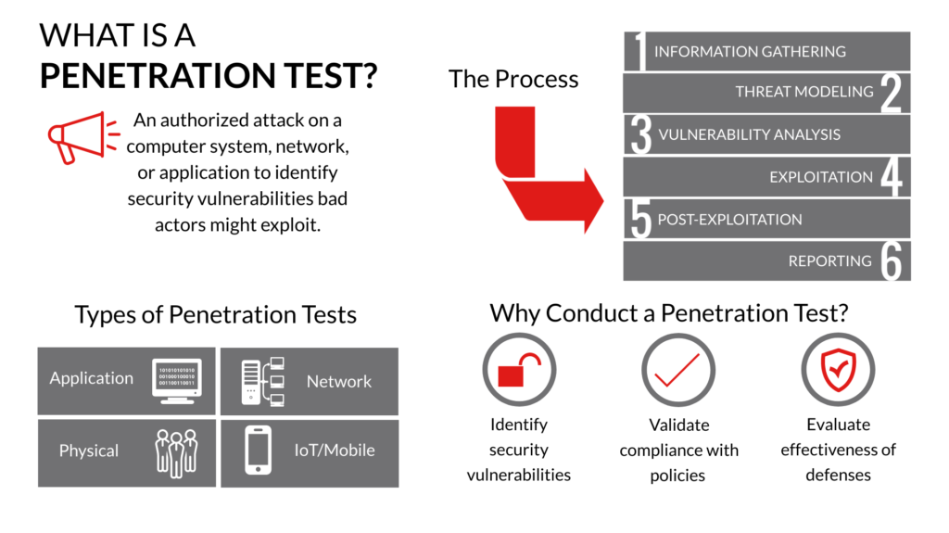It is also known as pen testing and it is something that has emerged from computer concerns at some point in the 1960s. It is a legal security testing method to attack a computer system in order to discover any potential risks. If an application or a system is not secured, then an attacker can take authorised access to the relevant system. These security risks are considered to be accidental errors that occurs during the implementation or development part of a software. As these computer systems started to allocate more data, the security of the data is more crucial than ever. Penetration testing is very important today as the world of pen-testing is expanding in reputation and it is developing a very popular way to evaluate the businesses’ security problems and infrastructure (Helmus, 2020). In this kind of test a system is evaluated in order to see its capability to protect its applications, networks endpoints and also the consumers from internal and external risks.

**Figure 4. Types of Penetration Testing (Source: Google)**

There are four types of penetration tests. **Application** penetration tests type is able to detect potential application weaknesses that attackers might use in order to steal confidential information. So, by identifying the application weaknesses, can help the systems admins to create a stronger defence method that disputes your other security policies. **Network** penetration testobjective is to detect any weaknesses within the network. Attackers that are able to penetrate the network will move across the organisation in order to increase their chances of getting the right credentials to accomplish their objective. **Physical** penetration tests are also known as physical intrusion testing and it is able to identify any way of an attacker will be able to compromise any physical obstructions of an organisation, such as cameras, locks, or sensors. This type of test is used to test the possible vulnerabilities of all the physical security mechanisms of an organisation and helping to take the right actions to prevent unauthorised people from gain access to buildings properties. **IoT/Mobile** penetration tests are able to identify any software and hardware weaknesses between the systems’ connected machines that are not covered by the typical network penetration test. Examples of common devices vulnerabilities could be the use of insecure protocols or the unencrypted data.

Penetration tests should be performed regularly to ensure the function of a system as it is an essential factor for preventing unauthorised access to organisations’ resources. It should be performed any time when a security system detects any kind of threat from an attacker, when the system installs a new system or updates it, a new network infrastructure is added, after an office relocation or after a new a new end-user policy/program taking place. There are five phases of performing a penetration test.

* **Planning & Investigation –** it is the planning stage of the pen test and it includes defining the priorities, scope, and goals to be achieved after performing the test. It also involves the gathering information process where you need to understand the target systems by determining its potential entry points and how a target works.
* **Scanning –** in this stage is more like a tool-oriented stage where a scanner tool is used to collect more information about the target. By using such scanners such as port scanners, vulnerability scanner and network mappers, the penetration testers are able to obtain many weaknesses which they can use to attack the selected target.
* **Exploitation & Gaining Access –** is where the penetration testers attempt to create a connection with the selected target in order take advantage of the weaknesses found in the previous stage. Here is where the information is extracted from servers by using different tools in order to get access.
* **Maintaining Access –** after gaining the access in the previous stage, it has to be maintained so that the pen tester is able to gain more in-depth access to more information and vulnerabilities. The main goal here is to detect complex constant threats that regularly stay in the system without being found.
* **Analysis & Reporting –** this final stage is where the all the results obtained from the penetration test should be added into a detailed report. It consists of all the weaknesses found and the sensitive data that was accessed.

When a penetration testing will be performed in the UK, there are a couple of laws which have to be follow in order for the test to be 100% legal and not considered a real attack. For most of the tests, the next following laws have to be followed:

* UK Data Protection Act 1998
* Human Rights Act 1998
* UK Computer Misuse Act 1990
* Police and Justice Act 2006

In order to make sure that the penetration testing is conducted in line with the UK regulations and also to certify that the pen test is performed as effectively as possible, sometimes a test consent form is one of the best choices to capture the exact objective of the test and also to allow a company’s infrastructure to understand your exact test scope so that they will allow you to perform such a test. In the past, penetration testing a cloud environment was slightly restricted because of their geographical and legal barriers. Penetration testers were not permitted to perform intrusive security pen tests or security scans on cloud-based environments and applications without the clear permission obtained from the cloud service providers such as Amazon Web Services, AliCloud or Microsoft Azure. But with the number of cyber-attacks aiming the cloud continued to grow in the recent years, the way of obtaining the approvals to perform a penetration test has changed. For example, back in 2019, the CapitalOne data breach occurred and showed that a misconfiguration in the access control on AWS known as (IAM) configuration was sufficient for an attacker to acquire the right credentials to illegally gain access to Amazon S3 buckets and be able to retrieve important information from this service. So, know a lot of organisations are hiring and looking for third parties’ companies to conduct penetration tests of their cloud infrastructure but only under restricted circumstance.

## 2.3 Overview of Penetration Testing the Cloud Environment

Vulnerability is the main important start point of cyber-attacks and simply investigating the potential weaknesses in a system is not enough in order to close all the system security issues. Performing a penetration test is one of the most used ways in order to get a better in-depth understanding of any security issue that can be used to attack a system. Even if penetration testing is a very important method used to detect potential system security issues, it could actually harm the entire system with excessive traffic and it can lead to a denial of service known as DoS (Abendroth et al., 2015). In their review paper about vulnerability assessment and penetration testing in cloud environment, Yurtseven and Bagriyanik (2020), stated that the above concern can be very problematic and difficult because all the systems in the cloud are connected and also depend on the internet. Based the statement is clear and it means that using such a test in a cloud environment is very complicated as all the other customers could be affected. One of the methods used to make sure that not everyone is affected is to perform a pen test in an isolated environment where the other customers will not be affected.

In one of his papers, Ali, Khan and Vasilakos (2015) presented a full explanation of the cloud environment infrastructure and also the distinct existing cloud models by underlining the security risks aiming the communication layer, virtual network vulnerabilities and the user restricted control on their data. This diversity of the cloud computing models come with a big risk where the attackers are aiming the cloud infrastructure. From the security point of view, it is very important to understand that the security paths which the attacker could take advantage of can damage the cloud system. These main paths are appreciated by Khorshed, Ali and Wasimi (2012) as security risks, trust issues and some more particular cloud associated issues which can affect the cloud environment. These authors also believe that a practical threat recognition model which utilises the modern machine learning procedures is able to identify and categorise the attack when it arises, notifying the associated parties, such as the system admins, about the type of attack by investigating the pattern to obtain more information about the incoming attack in order to take the right combating actions.

## 2.4 Amazon Web Service

It is a one of the world’s most broadly and complete adopted cloud platform system with over 200 fully highlighted services from data facilities worldwide, from computing storage and resources to media services and machine learning. The main aim of this project is to perform a penetration test of the Amazon Web Service which is one of the most used cloud computing platforms in the world. According to the global market share of Q1 2021, AWS is the leading cloud infrastructure service provider. This market dominance of Amazon Web Services over the years is the main reason why this cloud provider was chosen to be the cloud environment where a penetration test will take place. The AWS can be legally pen tested but the testers need to follow a list of policy permitted services and prohibited activities when performing a penetration test.

### 2.4.1 AWS Services

Many AWS services are built on the SaaS (Software-as-a-Service) model, check figure 2, which indicates that the end users cannot pen test it the same way as IaaS (Infrastructure-as-a-Service) model because the user does not own the environment. Due to this regulations, a couple of AWS permitted services were picked to conduct the penetration test as part of the project. AWS customers are able to perform a penetration test against the AWS infrastructure without the need for prior approval for the following services: Amazon EC2, Amazon S3, Lambada, RDS, API Gateways, Aurora, LightSail, and Elastic Beanstalk.

### 2.4.2 Elastic Compute Cloud (EC2)

It is a core element and one of the most used service of Amazon Web Services also known as EC2 and it is one of the first three primary service subscriptions. This service provides a mountable compute capacity on pay-per-use or an on-demand foundation to its users. It actually supports service virtualisations able to spin up virtual machines that are known as ‘instances’ in the Amazon Web Services environment. The virtualisation technology of the Amazon Web Services is based on these images and instances. The ‘instances’ could be launched using the preconfigured templates known as AMI (Amazon Machine Images) and it contains a software application and an operating system such as a web server. Another service for EC2 instance is the ‘instance metadata’ which is used to manage and configure the running instances (Instance Metadata, 2021). This ‘metadata’ can be retrieved using a private HTTP interface but only from the virtual server and its data is not protected by any cryptographic approach.

### 2.4.3 Amazon S3

This second service it is also one of the first three primary service subscriptions and it is a highly mountable storage capacity as a service having infinite capacity. The ‘bucket’ is the fundamental element of this service that performs as a logical packet and also stores items which are called ‘objects’ in the Amazon Web Service terminology. The ‘value’ and ‘key’ are the two major proprieties of the object.

### 2.4.4 Amazon S3

The third service here is the AWS Lambada which is a cloud computing implementation service module that responds to events by running code and also automatically handles the core compute resources. This actual code can be activated by modifying an object in an Amazon S3 bucket or also a DynamoDB table update will activate the code as well. Also, using an application can trigger the code as well. This code is known as a ‘Lambada function’ and it runs on AWS Lambada. Also, every single Lambada function consist of structure information such as the runtime environment and the function name.

### 2.4.5 Amazon RDS

It is a distributed relational database service (RDS) is a controlled SQL relational database service used in AWS to setup, scale and operate databases in the AWS cloud environment. It comes with a very good cost-efficient and flexible size capacity at the same time powering time-consuming processing tasks such as backups, database setup, hardware provisioning and patching. This service is available on a few database ‘instances’ forms optimised for performance or memory and delivers six family database engines that can be used in AWS such as Amazon Aurora, MySQL, Oracle Database, Maria DB, SQL Server and PostgreSQL. Another extra feature is the possibility of using the AWS ‘Database Migration Server’ to simply replicate or transfer your existing or current database to Amazon RDS service.

## 2.5 AWS Penetration Tools

There are a lot of tools in penetration testing that pen testers can use to meet all the needs. All these tools are able to improve efficiency, program certain tasks and also discover problems that can be complicated to get using manual methods alone.

### 2.5.1 Kali Linux

It is a Debian-derived Linux distributed designed for penetration testing and digital forensics. Over the past few years, Kali Linux has become very popular because of the fast-growing importance of the security. Actually, it has become an essential tool for anyone working in the penetration testing and security auditing industry because it comes with a preloaded bundle of security and penetration testing tools that do not need to be physically installed.

### 2.5.2 NMAP

It is a fantastic tool which is pre-installed in the Kali-Linux machine and it is an open-source tool normally used by network admins. This is a very popular tools in the penetration testing area because of the tool ability to locate open ports and services on various hosts at once and it is mostly popular across port scanning. This port scanning is actually performed by investigating a specific port and if that particular port is open, the tool will send back information about the port state. There are also a couple of scripts that NMAP can run in order to tell you if the particular scanned host has weaknesses to a certain issue. A port can be scanned by using this command: nmap -sV -SC -p < port number> <targeted IP>. The -sV switch is able to specify the service version, -sC switch is based on using scripts in combination with the scan and the -p switch suggests what ports are to be scanned.

### 2.5.3 Metasploit

It is a popular tool used in penetration testing and it is known as Metasploit framework. It is an automated software which also come pre-installed on Kali Linux with payloads and exploits that can actually be launched and configured at exposed ports. It comes with exploits relevant to all operating systems and also payloads of several categories. These exploits are created in *Ruby* and are knows as modules.

### 2.5.4 PACU

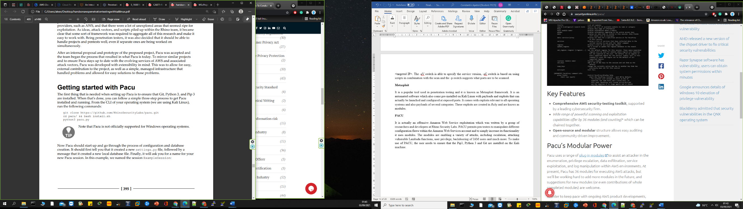It is actually an offensive Amazon Web Service exploitation which was written by a group of researchers and developers at Rhino Security Labs. PACU permits pen testers to manipulate different configuration flaws within the Amazon Web Services account and to simply increase its functionality it uses modules. The modules are enabling a variety of attacks, including escalation, attacking vulnerable Lambada functions, user privilege, backdooring of IAM users and much more. To make use of PACU, the user needs to ensure that the Pip3, Python 3 and Git are installed on the Kali machine. The following command needs to be performed in the terminal in order to ensure that PACU can work:

### 2.5.5 PuTTY

It is a tool that permits admins to remotely gain access to their system and it is an open-source and free terminal emulator, network file transfer app and serial console. PuTTY supports a variety of network protocols including SSH, SCP, rlogin, raw socket connection and Telnet and it can also be connected to a serial port.

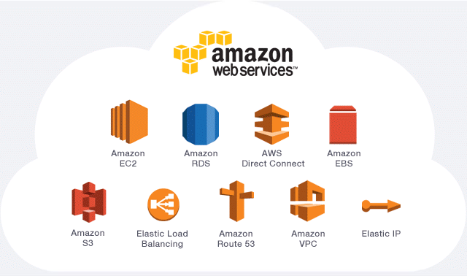

**Figure 5. Amazon Web Services (source: ThinKwik)**

# Chapter 3 – Methodology

## 3.1 Research Methodology

This section of the paper includes the search process used to obtain all the enough evidence in order to have enough arguments to answer the research question. According to Chandane and Bartere (2013), this type of process is playing an important role in obtaining reasonable and qualitative results. In this thesis, the search process is carefully executed in order to collect and extract all the related studies needed for the project based on two main factors: search string and assets. The search string was performed based on the listed questions in the RQ section and consists of the following steps:

* Obtaining the key terms of the thesis research questions.
* Listing all these key terms synonyms.
* Confirming the appropriate thesis search terms.
* Combining the search terms found with the BOOLEAN operators.

The paper keywords are the following: penetration testing, cloud environment, security. This are the main keywords of this thesis and using them a search string will be generated. Based on the results the following search string was established:

**("pen testing" OR "penetration test" OR "penetration testing" OR "testing") AND ("cloud") AND ("environment" OR "computing" OR "services") AND ("security")**

**Note:** The Boolean terms that have been used to generate a search string are used between the keywords as an element of the search string because they are actually different type of combinations applied in order to merge or exclude the selected keywords in a search string process. For instance, the **OR** operator is used here to join 2 or more keywords forming a union between its two operands and using it will let the database know that you only need either or both terms to be displayed in your final search list. Also, every time when two keywords are joined using the **OR** operator, they have to be enclosed in brackets. The **AND** operator is used to combine two keywords enclosed by a bracket so that the database will know that both keywords need to be displayed in the final search list. So, the **AND** operator can execute an intersection of its two operands and if only one keyword is included in the selected document and the other one is not included then the item will not be included in the final search string list. (Sunny Empire State College, 2020).

Choosing the best search string is not that easy and it requires a bit of testing the strings to see which one should be the final one. Due to these tests that are part of the literature search process, the following list displays the search strings tested and it is considered to be the dismissed search string list:

* ("pen testing" OR "penetration test" OR "penetration testing" OR "testing") AND ("cloud") AND ("environment") AND ("services") AND ("computing")
* (“pen testing” OR “penetration testing”) AND (“cloud”) AND (“environment”) AND ("computing")
* (“penetration test”) AND (“cloud environment” OR “cloud services”) AND (“security” OR “safety” OR “reliability”)
* (“pen testing” OR (“penetration test”) AND (“cloud environment” OR “cloud computing”) AND (“services”) AND (“security” OR “reliability”)

As part of the systematic literature search process, a few electronic libraries were searched using the generated search string in order to obtain a number of papers such as magazines, journals, books, articles, and conferences that were used in completing the project. The study strategy selection is also very important because it needs to be defined at the practice to select the most significant studies in the well-defined scope. By performing a well-defined study search process, around 700 papers were gathered. But to sort out these collected studies to make sure the most relevant ones have been selected, there are two stages in the selection process that can help in filtering the sources and the use of the inclusion & exclusion criteria procedure is needed. So, the search string obtained was used as part of this criteria procedure to make sure that the selected papers are related to our main subject. So, using the command search string in our electronic libraries, a list of different types of papers were generated using the search string: ("pen testing" OR "penetration test" OR "penetration testing" OR "testing") AND ("cloud") AND ("environment" OR "computing" OR "services") AND ("security"). The numbers of papers generated was too big so that is why the inclusion & exclusion criteria was used here, see table 1.

|  |  |
| --- | --- |
| **Inclusion** | **Exclusion** |
| Publications written in English. | Publications that are not written in English. |
| Publications that include or are related to penetration testing. | Publications that do not include penetration testing examples or technical details. |
| Publications that include or are related to cloud security and Amazon Web Services. | Publication not related to cloud environment, cloud computing or cloud services. |
| Publications that are related to the selected research questions based on their keywords, title or abstract | Publication that does not involve cloud computing applications or cloud computing testing. |
| Publications that were published in the last 5-10 years. | Publications that were published over 10 years ago. |
| Publications related to the cloud security. | Publications that are not related to penetration testing the cloud environment. |
| Publications related to AWS cloud services. | Publications which contain technical details about other cloud providers except from AWS. |
| Publications containing penetration testing tools and techniques. | Publications that are not related to cloud computing, security, or environment. |

**Table.1 Inclusion and Exclusion Criteria**

All the generated papers were filtered based on a well-defined set of rules of the above criteria. Studies that focus on the penetration testing, cloud environment, cloud systems, cloud computing or security and the studies which contained at least one reasonable answer to our specific research question by analysing their keywords, titles and the abstracts sections were also included. Also, the non-English papers and the papers containing networks, hardware testing or other fields rather than our criteria were excluded, see table 1. The search was performed including the above criteria and it was applied on every abstract, title, or keywords on the selected electronic libraries. The number of matches after the inclusion and exclusion criteria was included in the study search matched around 70 papers. The next part of the research process was the reading and analysing all the papers obtained from the final search activity and only the publications that were directly involved in developing the thesis were carefully chosen. During the data extraction, which was also an important part of the project, as the information needed for the thesis was selected by taking references and notes of every single paper that can be used in addressing the research question. This step was done by extracting important information from the analysed papers such as solutions, suggestions, limitations, and results sections. Having enough information is very important as it involves a lot of reading in order to get an overall understanding about the thesis subject and to successfully finish the started project. A number of citations were used from the final papers selected as part of the project because they were used as strong arguments for the findings regarding the thesis research question and topic.

## 3.2 Cloud Pen Testing Methodology

The methodologies usually used to penetration test conventional security organisation and the Amazon Web Services Cloud are very different in a variety of ways. The majority of these differences are about to the possession of the system. Ever since Amazon is the holder of the main infrastructure, the actual methodology requested using the traditional *ethical hacking* would in fact breach the Amazon Web Services standard policies and this will lead to the response procedure call by the AMWS defence team which will block the methodology invoked. So, the pen testing the AWS must aim the user-owned resources, identify, and gain access to the management user agreements configurations and also the use of the AWS API which are genuinely incorporated into the Amazon Web Services eco-system. For example, compromising and targeting the AWS ‘IAM Keys’*,* establishing access using the ‘Lambada’ backdoor functions, testing S3 bucket permissions and configuration errors and obscuring ‘CloudTrail logs’ to be able to cover tracks are strategies used to attack the Amazon Web Service Cloud Environment but they also require specific approach and knowledge in order to not turn the attack from a legal one to an illegal one.

That is why the penetration test performed for this thesis will take place in accordance with the knowledge gained from reading, researching, and studied during the cyber security course so that I can actually test my knowledge to a different level and also to improve them.Every single stage of a pen test develops the results gained from the previous stages, so the order of the stages will remain unchanged. This entire process involves ‘pivoting’ which means that these stages will be repeated in order to gain access to more assets (Engebretson, 2013).

Many penetrations tests methods depend on the security system and the degree of enthusiasm of the organisation or individual. There are 3 types of penetration testing methods and they depend on the type of information a pen tester has; these methods are identified as:

* Black box: this assessment is conducted with not too much information provided to the penetration tester. The tester is very limited here and there is also a reduced information about security control infrastructure or the system. The reconnaissance approach will need to be used in order to obtain the necessary information about the security infrastructure and the system.
* White box: in this assessment, the consultant or the tester is supplied with enough information and also with detailed documentation about the system’ applications, infrastructure, equipment and security management such as the source code, architecture documents and more. This method is able to detect and identify both internal and external weaknesses.
* Grey Box: in this assessment, the pen tester is supplied with user-level information and knowledge required to evaluate the security management system. The penetration tester is allowed inside the system with limited knowledge and controlled access to the internal network and web applications infrastructure.

### 3.2.1 Cloud Pen Testing Plan

The very *first phase* of the penetration testing is the reconnaissance, which means that gathering the information to determine the testing scope is first part of the plan. So, it is important to obtain as many details as possible because the more knowledge about the target is obtained, the more likely the penetration test will succeed.

* Scope is to identify the testing systems that will be inspected during the penetration test which are the permitted AWS services. As there are some restrictions to what we can actually pen test in Amazon Web Services and that only the AWS customers are able to perform penetration tests against the AWS infrastructure. A personal AWS account will be used here and a cloud environment will be set in order to perform a penetration testing on AWS cloud services.
* A set of pen tests will be performed in order to discover and exploit any vulnerabilities inside the own cloud environment and the following services will be tested: EC2 instance, targeting and manipulating IAM keys, S3 bucket permission flaws and lambada functions.
* The type of penetration test conducted will be a white box type because there will be a complete open access to the cloud environment and detailed information regarding the applications, infrastructure, security controls and the system’s equipment.
* The main expectations here is to try and find if there are any weaknesses in the settled cloud environment and if there is any vulnerability which can be used by an attacker to steal data.
* A list of tools will be used for scanning, exploitation and accessing the data inside the cloud environment such as: kali linux, nmap, Metasploit and PACU.
* AWS testing policy has been review and there is no need for a written approval in order to conduct such a test because the aim here is to try and find and manipulate the vulnerabilities of the permitted AWS cloud services which were stated above.

### 3.2.2 Cloud Pen Testing Execution

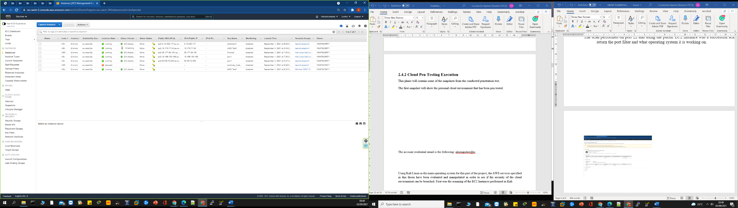This phase will contain some of the screenshots from the conducted penetration test. The first screenshot will show the personal cloud environment that has been pen tested. Also, there was used 2 Kali machines where the work has been done. The first Kali Linux machine was opened using Oracle VM VirtualBox for the external penetration testing and the other one was one of the AWS clouds EC2 instance which run Kali Linux using the PuTTY, which is a free open-source terminal serial console. PuTTY was used to run the Kali Linux instance using the created pair key and using the PuTTY generator obtain the private key in order to run the Kali Linux machine console. The console was used for the internal part of the penetration testing.

As you can see there are 7 instances up, 6 of them running and 1 stopped. On the right side you can see my name shown and this is the AWS customer account used for the penetration test. Here, the instances were scanned one by one in order to see if the ports here are opened and what we can find about them.

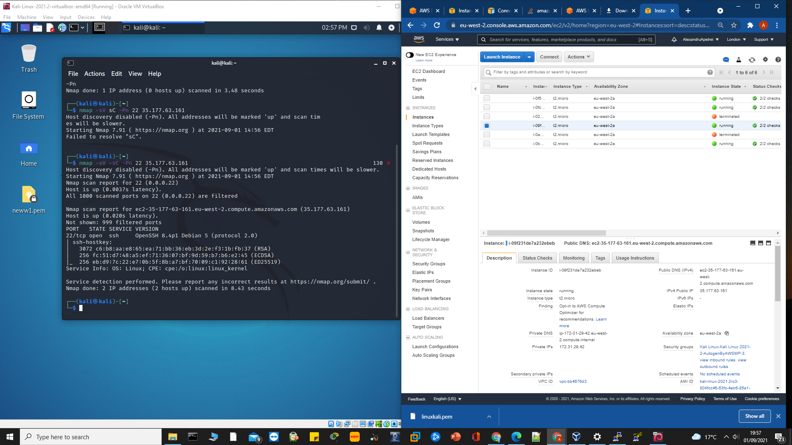Using Kali Linux as the main operating system for this part of the project, the AWS services specified in this thesis have been evaluated and manipulated in order to see if the security of the cloud environment can be breached. First was the scanning of the EC2 Instances performed in Kali

In this screenshot you can see that I have scanned one of the ports using the known victim IP because of the public instance created. Nmap command was used here to scan the port 22 and the outcome is that the port is a TCP one and it is opened. Note that the other IPs were also scanned in order to see if there is something to find.

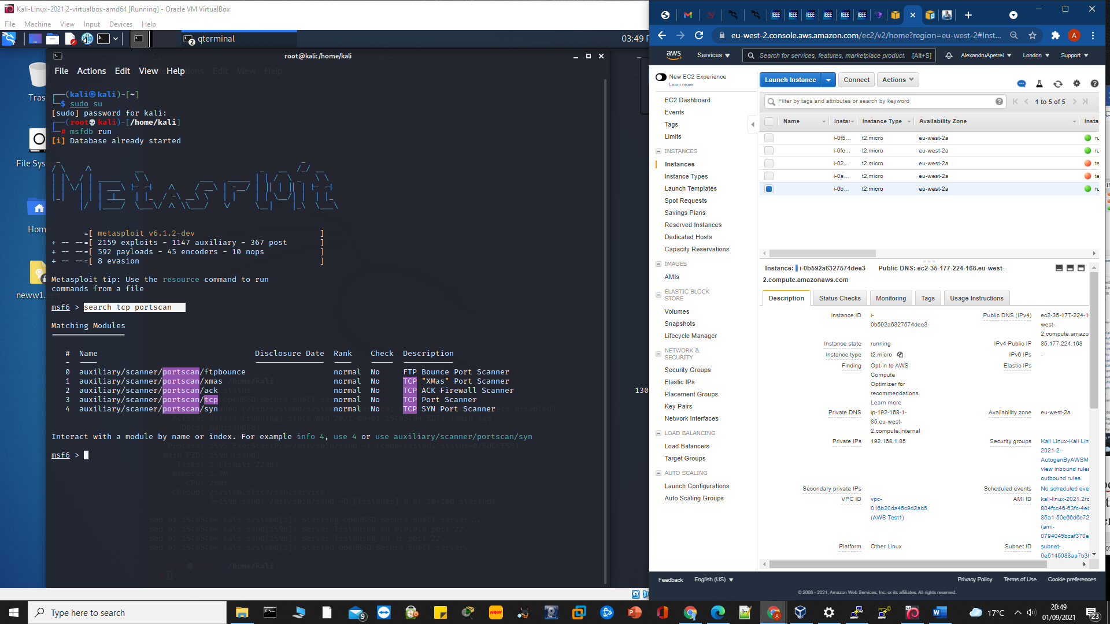

In this screenshot you can see that we have started the Metasploit with the command: “msfdb run” in order to get the Metasploit database up and running in order to get use of its scanners. Now that we have found out the above TCP port is opened. I have decided to dig deeper and I have started to search for a TCP port scanner.

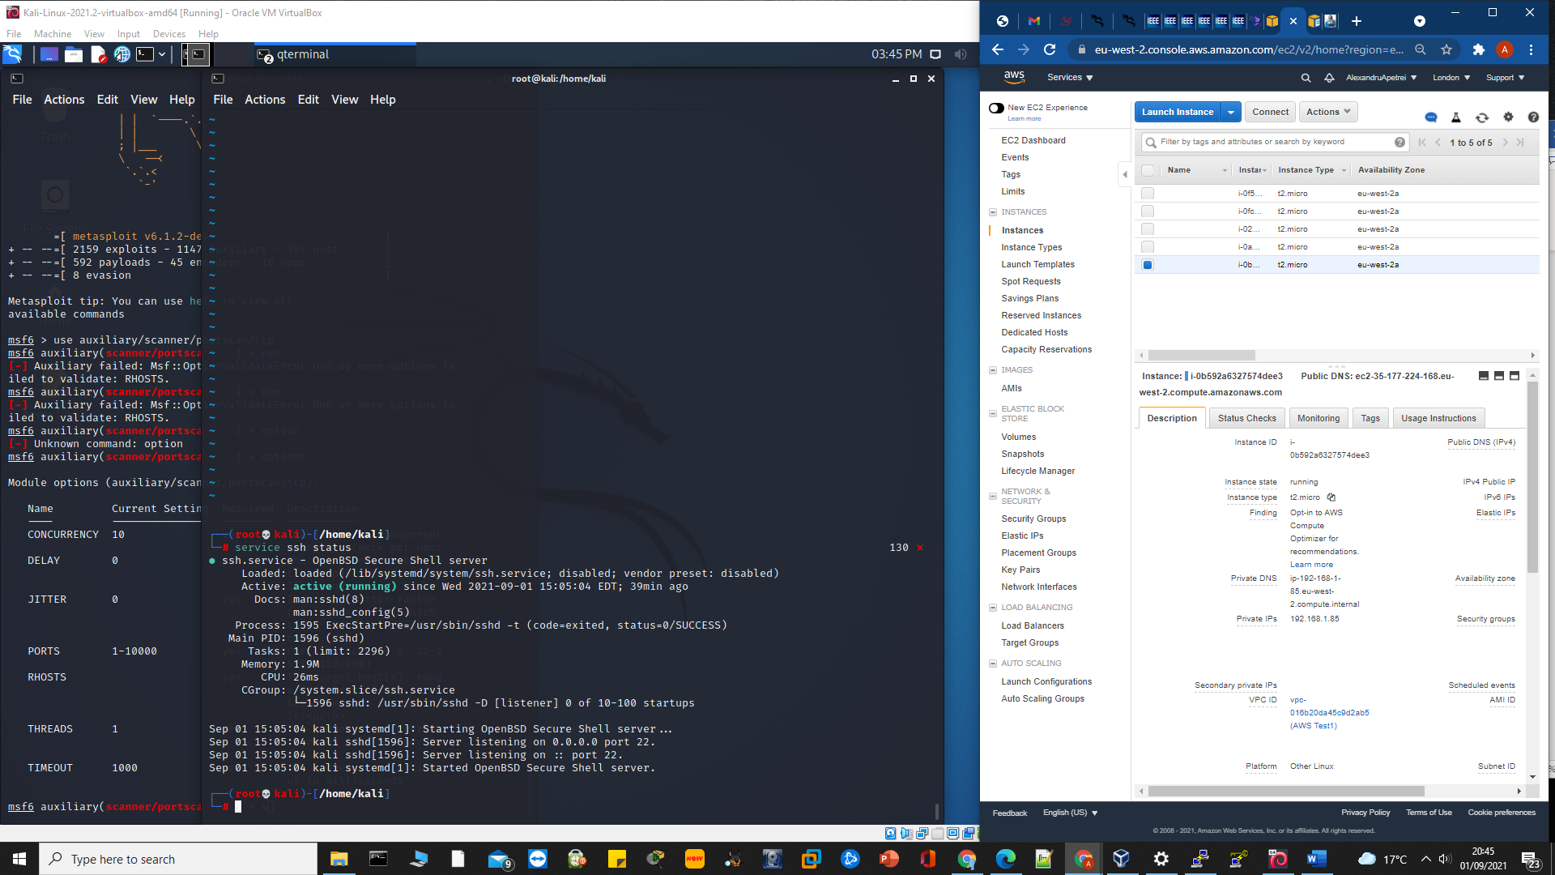

After Metasploit was running, I have opened another kali terminal and I have started the ssh server using command: “service ssh start”. In the screenshot you can see that I wanted to check the server status and the following command was used: “ssh start”. The server is up and running. The next step is to go back to the terminal where the Metasploit is opened and search for TCP port scanner in order to find and use the port scanner available to use.

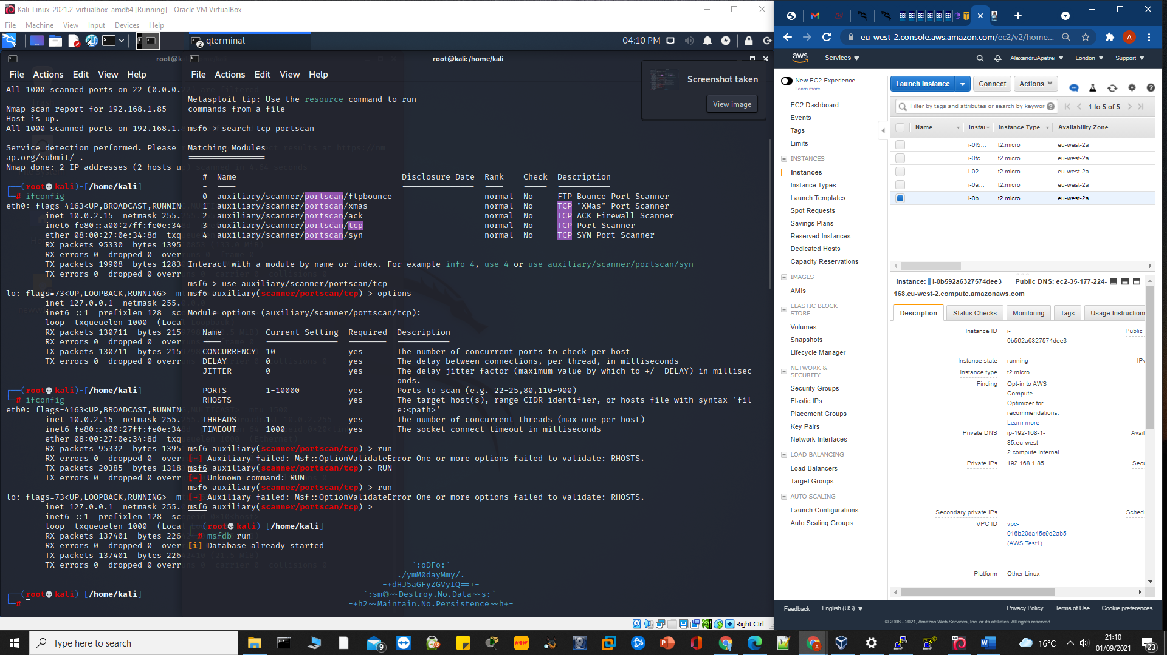Following the search command: “search tcp portscan” was used to display all the available TCP port scanner and you can see that the portscan and TCP words are highlighted because of the search command used.

I selected the scanner needed to perform the TCP scanner which is “auxiliary/scanner/portscan/tcp” and I have used the option command to display the module options. Rhosts is the module option picked as it is used for remote host and also used to set a remote victim host as well. Here, the IP address of the machine is needed and to obtain it the command if config will be used.

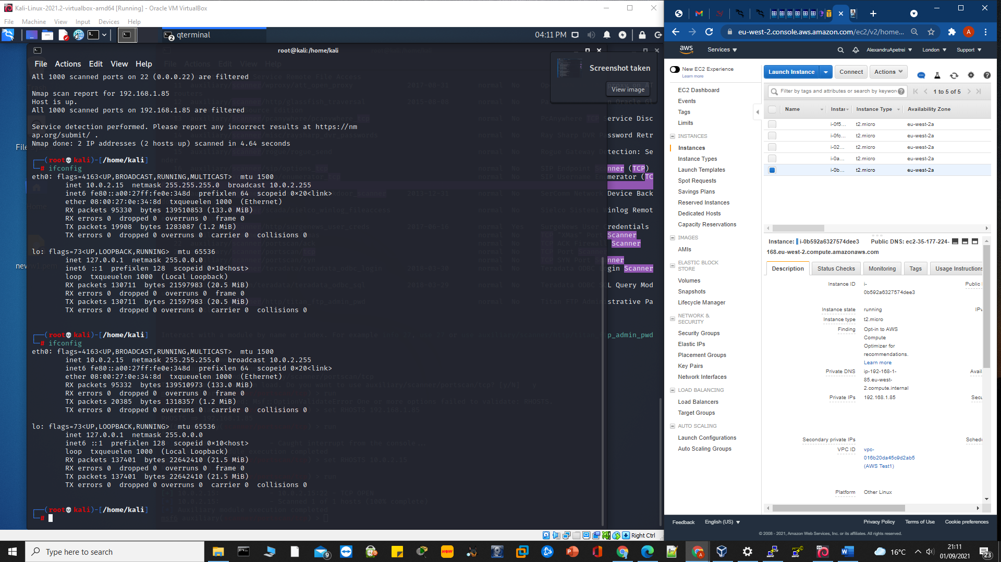

Opened another terminal and the command:” ifconfig” was run in order to identify the IP address of the machine that I am using is: 10.0.2.15 and the following command “RHOST 10.0.02.15” will assign the IP address to the RHOST constraint and it is the only one needed now. Going back to the other terminal where the TCP scanner is, the run command will launch the module against the host.

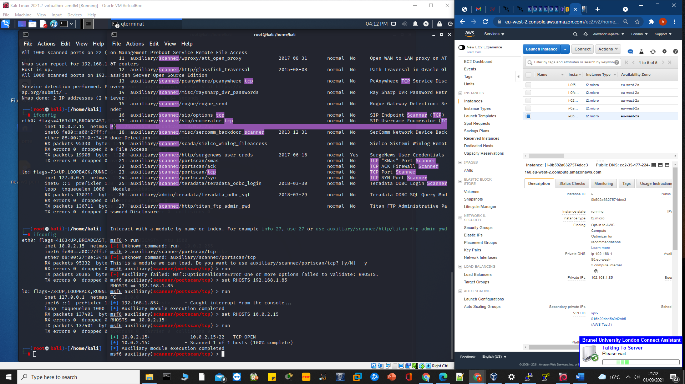As you can see, the port open is 22 and the output command shows that the host scan is 100% completed and results are displayed as port 22 – TCP open

This scanner was used for the Linux EC Instance from the cloud environment. Now the next scanner will be performed on Windows EC2 instance to see what we can find.

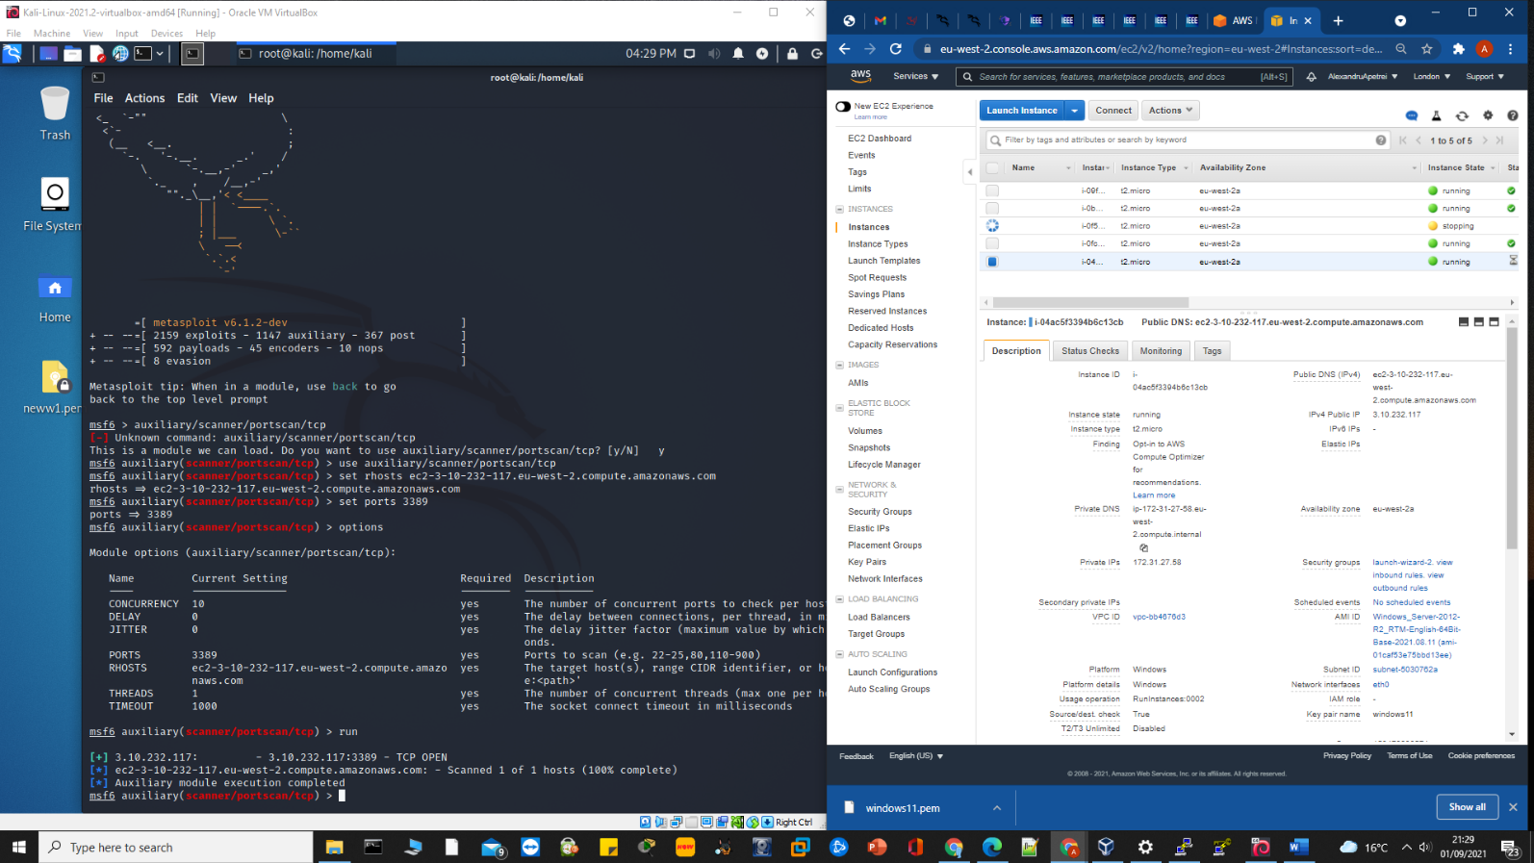

The test performed for the EC2 Instance – ec2-3-10-232-117.eu-west-2. compute.amazonaws.comm, this can be seen on the right side of the screenshot where the Windows Instance is up and running and it has the same instance I am trying to use the scanner to see if I can discover the host operating system using Metasploit scanning tools. As they are my AWS services, I know what the host is and also the DNS is public and the port number is 3389 by random for windows that is why I picked it to do the scan. The techniques used are to determine If I can scan the port more in order to see what the operating system is. We can also see that the port number IP address is 3.10.232.117 and the port 3389 showed as TCP OPEN.

Now I am going to use the ACK scanning using Metasploit to see if the scanned ports are filtered. If these ports are filtered then only specific traffic is allowed and only a particular host is able to use that port. This ACK scan is actually sending an acknowledge packet to the main target and the target machine is supposed to reset the host’s packet

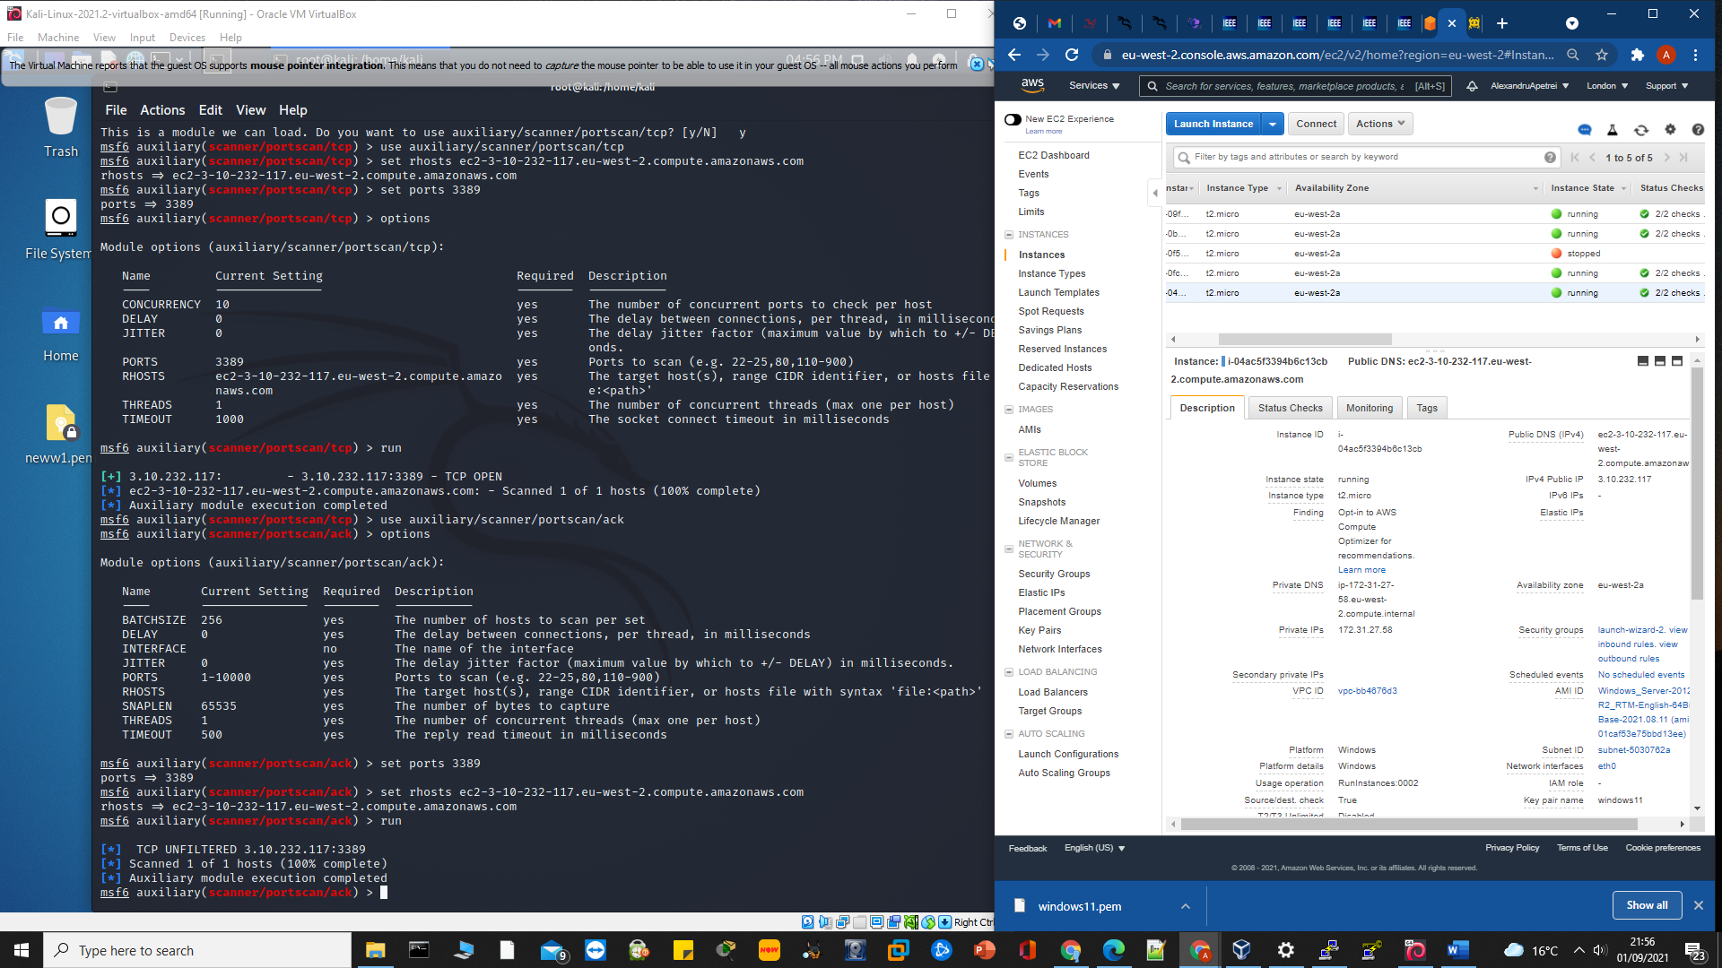The scan results show the port as not filtered, and now an attempt to move forward on this port is needed. 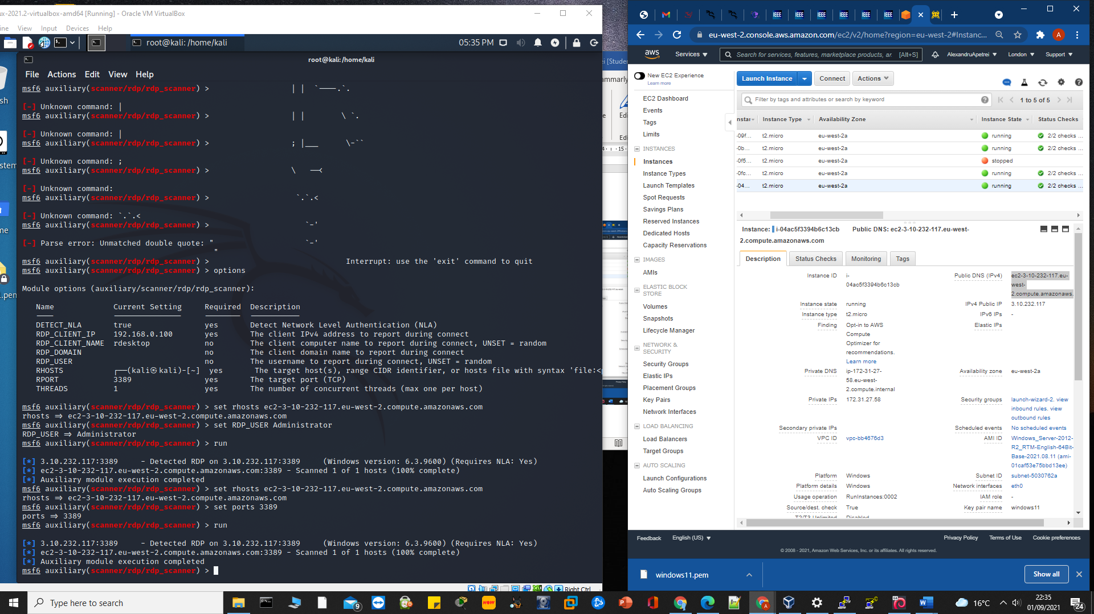Once I have found port opened and unfiltered, I have decided to move forward in order to see if the operating system is running here. This can also be done by using Nmap but I have decided to still use Metasploit as it was running and it takes time to close and start again with Nmap.

Using the method, I have used in the previously scanners, this time I have performed the scan usingrdp_scanner command to see if I can get some information about the operating system of the AWS host. Due to the unfiltered port, I have found that the host is using windows version 6.3 .9600 as the operating system. Also, after discovering that the port 3389 is unfiltered I have tried to access it but there is no result as the login credentials could not be found.

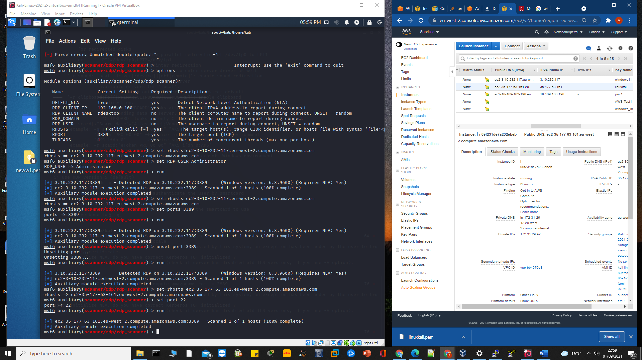

The scan performed on port 22 and using the public EC2 instance was a successful scan but did not return the port filter and what operating system it is working on.

That is how the penetration testing continued and PACU was also used to import key pairs from the AWS CLI into PACU by using the following command: “import_keys”. The reason why the personal user was added into AWS CLI and PACU is that the performing of the unauthenticated reconnaissance against the selected target requires the keys from outside the target account. I have continued to perform the penetration test in order to find any vulnerabilities within the system and all the findings will be presented into the Result section of the thesis. The following tests were executed using PACU as part of the pen testing process. Tests using PACU 🡪 Unauthenticated reconnaissance, permission enumeration + authenticated reconnaissance, privilege escalation, persistence, service exploitation + EC2 exploitation, Lambada analysis, trying to gather past authentication in AWS RDS, the authenticated side of S3 buckets.

# Chapter 4 – Results and Discussions

## 4.1 Introduction

As part of the penetration test, I have used an Oracle VM VirtualBox Kali machine and also a Kali Machine using PuTTY to run the EC2 instance in order to perform a penetration testing with the right approvals for the target assets which complied with the Amazon Web Service customer testing policy.

## 4.2 Foot Printing / Reconnaissance

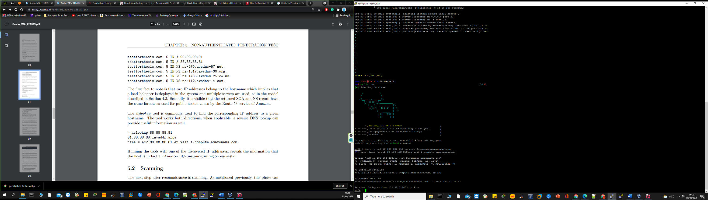Inspection performed against the cloud environment target to collect as much information needed in order to use for the further penetration phases. The host tool was used here to discover the targeted IP address which belonged to the source hostname. Also using “-a” switch will deliver a verbose output and also the possible additional information about the target.

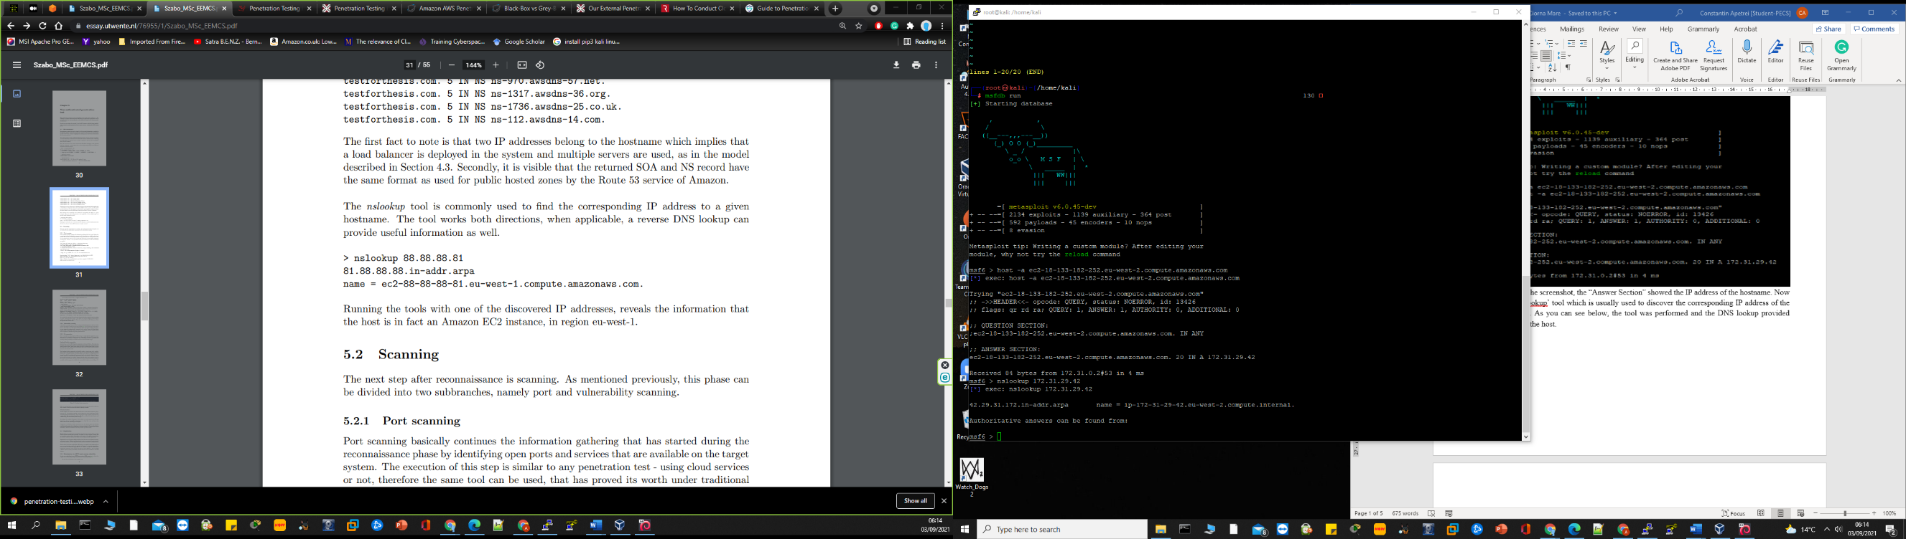As you can see in the screenshot, the “Answer Section” showed the IP address of the hostname. Now I will use the ‘nslookup’ tool which is usually used to discover the corresponding IP address of the selected hostname. As you can see below, the tool was performed and the DNS lookup provided information about the host.

Running the ‘nslookup’ command with the IP address we can see that reveals information about the host. As you can see, the host is using an Amazon EC2 instance and its region is eu-west-2.

## 4.3 Scanning

This next step is used after the reconnaissance and this phase can actually be split up into two subbranches such as vulnerability scanning and port scanning.

### 4.3.1 Port Scanning

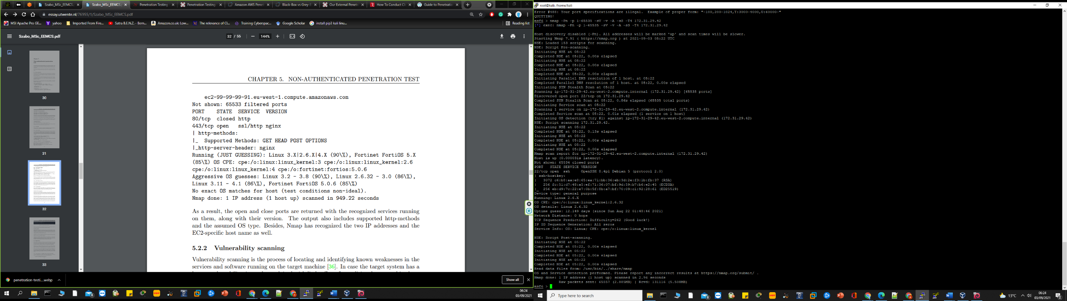The execution of this step is similar to any pen test using cloud services or not but also the same tool can be used for such a test. I have used the command: nmap “-Pn -p 1-65535 -sV -v -A -sS -T4 <host IP ADDRESS)”. 1-65535🡪will display all available scanned ports).

As the result shows, the all the open and closed ports returned back with all the established services running on them and it also contains their version data as well. The ssh-hostkey were also displayed with the number of port 22/ tcp open and nmap also recognised the EC2 individual host name as well.

### 4.3.2 Vulnerability Scanning

This is process of identifying and detecting common vulnerabilities in the software and services running on the target machine. Just in case the selected target system has a recognised weakness, it can be exploited with some effort. He next automated tools were used in order to expect the possible weakness found: Nmap script and Nessus. Well, at least 1 vulnerability has been identified in the port scanning process and it will be exploited in the next phase of the pen test.

## 4.4 Exploitation

This third step of the pen test involves active intrusion challenges that are used to confirm that the system is actually vulnerable to a cyber-attack. An exploit its an actual way to avoid a security issue or bypass security controls. It depends on the gravity of the manipulated weakness, the expand in which the attacker can gain control around the particular target may well vary considerably. So, after interpretation of all the findings from the vulnerability scanning, I have used a set of manual techniques and tools to be able to attack, exploit and validate the findings from the previous stage such as nimbostratus which is actually a set of tools used in exploiting and fingerprinting Amazon cloud systems and it has been developed by Andres Riancho.

## 4.5 Post Exploitation

This stage deals with the covering the activities performed on the previous stages and it concentrates on obtaining as much information as possible from the system, without letting the system owner notice the occurrence of an attack. This stage is dealing with the gathering of delicate information and also to discover any configuration setting that can be used to maintain the access to the system. This stage corresponds to the authenticated penetration test where the attacker is in control of the credentials and its able to gain access to EC2 instance.

## 4.6 Discussion

Thinking about the entire process, the summarised method and the proposed tools can be used on any application running within the Amazon cloud environment. After completing the first two phases of the penetration test, several signs can expose the fact that the AWS services are used and this might lead the attacker to an exploit of the metadata service. Concerning the remaining two phases of the pen test, some tools have been used to exploit the findings but the only problems found were based on the EC2 instance public IP and the instance not being fully secured because it has not been created as a fully secured instance and it could actually cause a cyber-attack. Due to the “New EC2 Experience” which can be found on the top left of the side of the EC2 instances Dashboard will allow you to select it in order to see new instances experience and if you go and create a new instance after you clicked on the “New EC2 Experience” will not allow you to create a new instance without telling you that its settings are too weak and that this could lead to a big vulnerability.

Developing my thesis, I had the chance of putting in practice my research and technical skills gained during the past two years studying the subject and I have also learnt some new programs, tools, techniques, and I had an in-depth understanding of what a penetration testing really is and how important it can be.

# Chapter 5 – Conclusion

The main conclusion here is clear, a penetration test is not considered an option anymore, as it is the only way to test and demonstrate that the cloud-based infrastructures, applications, and data are protected as much as needed in order to allow the maximum amount of user access with the lowest amount of risk. To answer one of the security questions I have added in this thesis, all I can say is that the AWS pen testing is actually a massive process which involves a wide range of knowledge and commitment because this type of pen test is a never-ending process. There are always new functionality and services being issued by the Amazon Web Service so this means that there will always be some new security checks or potential attacks for those services. From a penetration tester point of view, I think it is very complicated to be able to say when you are done penetration testing an Amazon Web Service environment because of how complex and gigantic they can turn out to be. The use of penetration testing on the cloud environment is very important as the number of data breaches will continue to rise as new security procedure are implemented.

There will always be some ways of attacking or taking advantage of some small mistakes in order to penetrate the system. Keeping the cloud environment secure is very important and I think that performing an individual cloud penetration test is too much and is not going to be too successful as there are many organisations out there which have more knowledge on how to simulate an attack of the cloud services in order to obtain some vulnerabilities. Amazon Web Services have a lot of legal and technical aspects and some of them are really not really to understood and very complex as well. Also, a penetration testing should be performed regularly to ensure the function of a system as it is an essential factor for preventing unauthorised access to organisations’ resources. It should be performed any time when a security system detects any kind of threat from an attacker, when the system installs a new system or updates it, a new network infrastructure is added, after an office relocation or after a new a new end-user policy/program taking place. There are five phases of performing a penetration test

One of my future works could be to conduct a group penetration test and comparing it to the one I have performed in order to see which one is more efficient and what are the improvements rates. Working with a penetration testing team in an organisation is one of my possible next adventures and comparing the piece of individual work performed for this thesis with the group work in an organisation will be a very good work approach.

# Chapter 6 – Bibliography

Ali, M., Khan, S.U. & Vasilakos, A.V. (2015) ‘Security in cloud computing: Opportunities and challenges. *Information Sciences.* vol.305, pp.357-383.

Blanchard, J. (2020) The History of Cloud Computing. *Server Mania.* [Online]. Available at: <https://blog.servermania.com/the-history-of-cloud-computing/>. [Accessed: 12 August 2021].

Garrison, G., Kim, S. & Wakefield, R.L. (2012) ‘Success Factors for Deploying Cloud Computing’. *Communications of the ACM.* 55 pp.62-68.

Hussein, N.H. & Khalid, A. (2016). ‘A survey of Cloud Computing Security challenges and solutions”. International Journal of Computer Science and Information Security.

Instance Metadata and User Data (2021) *AWS.* [Online]. Available at: <https://docs.aws.amazon.com/AWSEC2/latest/UserG>. [Accessed: 10 August 2021].

**Jabir, R.M., Khanji, S.I.R, Ahmad, L.A., Alfandi, O. & Said, H. (2016). ‘**Analysis of cloud computing attacks and countermeasures’. 2016 18th International Conference on Advanced Communication Technology (ICACT). pp.117-123.

Jain, A. & Mahajan, N. (2017) ‘Introduction to Cloud Computing’. *The Cloud DBA-Oracle.* pp. 3-10.

Khorshed, M., Ali, A. & Wasimi, S. (2012) ‘A survey on gaps threat remediation challenges and some thoughts for proactive attack detection in Cloud computing’. Future Generation Computer Systems. vol.28, no.6, pp.833-851.

Krtuz, L.R. & Vines, R.D. (2010) *Security: A Comprehensive Guide to Secure Cloud Computing*. *Wiley Publishing.*

Marinescu, D.C. (2018) *Cloud Computing Theory and Practice.* 2nd ed. Cambridge: Morgan Kaufmann.

Marston, S., Li, Z., Bandyopadhyay, S., Zhank, J. & Ghalasasi, A. (2011) ‘Cloud Computing-The Business Perspective. Decision Support Systems. vol.51, issue.1, pp.178-189

**Miller, M. (2008)** *Cloud Computing, Web Based Applications That Change the Way You Work and Collaborate Online.*

Mlitz, K. (2021) Cloud infrastructure services vendor market share worldwide from 4th quarter 2017 to 2nd quarter 2021. *Vendor market share in cloud infrastructure services market worldwide 2017-2021.* Abstract [Online]. Statista [Accessed 22 August 2021].

Monica, R., Dinesha, H.A. & Agrawa, V.K. (2013). ‘Cloud computing - Phone call as a service: A concept’. 2013 International Conference on Advances in Computing, Communications, and Informatics (ICACCI). pp.236-242.

**NIST. (2021)** *Final Version of NIST Cloud Computing Definition Published*. Available at: <https://www.nist.gov/news-events/news/2011/10/final-version-nist-cloud-computing-definition-published>. [Accessed: 03 August 2021].

Singh, S.H., Jeong, Y.S.H. & Park, J.H. (2016). ‘A survey on cloud computing security: Issues threats and solutions’. Journal of Network and Computer Applications. vol.75, pp.200-222.

Stergiou, C., Psannis, K.E., Kim, B. & Gupta, B. (2018). ‘Secure integration of IoT and Cloud Computing’. *Future Generation Computer Systems*. pp.964-975.

Yurtseven, I. & Bagriyanik, S. (2020). ‘A Review of Penetration Testing and Vulnerability Assessment in Cloud Environment’. *2020 Turkish National Software Engineering Symposium (UYMS).* pp.1-6.

Zimba, A. & Wang, Z. (2017) ‘On Man-In-The-Cloud (MITC) attacks: The analytical case of Linux’. *2017 IEEE Internet Conference on Intelligence and Security Informatics (ISI).* pp. 170-172.

# Chapter 7 – Appendix

**PORT SCANNING – TERMINAL CODE – Kali Linux**

**NMAP, Metasploit and Scanners -- Not full PenTest Code Submitted – it is too much**

login as: kali

Authenticating with public key "imported-openssh-key"

Passphrase for key "imported-openssh-key":

Linux kali 5.10.0-kali7-cloud-amd64 #1 SMP Debian 5.10.28-1kali1 (2021-04-12) x8 6_64

The programs included with the Kali GNU/Linux system are free software;

the exact distribution terms for each program are described in the

individual files in /usr/share/doc/*/copyright.

Kali GNU/Linux comes with ABSOLUTELY NO WARRANTY, to the extent

permitted by applicable law.

Last login: Wed Sep 1 18:40:15 2021 from 82.10.177.224

┏━(Message from Kali developers)

┃

┃ This is a cloud installation of Kali Linux. Learn more about

┃ the specificities of the various cloud images:

┃ ⇒ https://www.kali.org/docs/troubleshooting/common-cloud-setup/

┃

┃ We have kept /usr/bin/python pointing to Python 2 for backwards

┃ compatibility. Learn how to change this and avoid this message:

┃ ⇒ https://www.kali.org/docs/general-use/python3-transition/

┃

┗━(Run: “touch ~/.hushlogin” to hide this message)

┌──(kali㉿kali)-[~]

└─$ sudo su

┌──(root💀kali)-[/home/kali]

└─# service start ssh

start: unrecognized service

┌──(root💀kali)-[/home/kali]

└─# service ssh start 1 ⨯

┌──(root💀kali)-[/home/kali]

└─# service ssh status

● ssh.service - OpenBSD Secure Shell server

Loaded: loaded (/lib/systemd/system/ssh.service; enabled; vendor preset: d>

Active: active (running) since Fri 2021-09-03 04:49:58 UTC; 13min ago

Docs: man:sshd(8)

man:sshd_config(5)

Process: 582 ExecStartPre=/usr/sbin/sshd -t (code=exited, status=0/SUCCESS)

Main PID: 588 (sshd)

Tasks: 1 (limit: 1140)

Memory: 5.2M

CPU: 66ms

CGroup: /system.slice/ssh.service

└─588 sshd: /usr/sbin/sshd -D [listener] 0 of 10-100 startups

Sep 03 04:49:58 kali systemd[1]: Starting OpenBSD Secure Shell server...

Sep 03 04:49:58 kali sshd[588]: Server listening on 0.0.0.0 port 22.

Sep 03 04:49:58 kali sshd[588]: Server listening on :: port 22.

Sep 03 04:49:58 kali systemd[1]: Started OpenBSD Secure Shell server.

Sep 03 04:57:37 kali sshd[758]: Connection closed by authenticating user root 8>

Sep 03 05:02:49 kali sshd[761]: Accepted publickey for kali from 82.10.177.224 >

Sep 03 05:02:49 kali sshd[761]: pam_unix(sshd:session): session opened for user>

lines 1-20/20 (END)...skipping...

● ssh.service - OpenBSD Secure Shell server

Loaded: loaded (/lib/systemd/system/ssh.service; enabled; vendor preset: disabled)

Active: active (running) since Fri 2021-09-03 04:49:58 UTC; 13min ago

Docs: man:sshd(8)

man:sshd_config(5)

Process: 582 ExecStartPre=/usr/sbin/sshd -t (code=exited, status=0/SUCCESS)

Main PID: 588 (sshd)

Tasks: 1 (limit: 1140)

Memory: 5.2M

CPU: 66ms

CGroup: /system.slice/ssh.service

└─588 sshd: /usr/sbin/sshd -D [listener] 0 of 10-100 startups

Sep 03 04:49:58 kali systemd[1]: Starting OpenBSD Secure Shell server...

Sep 03 04:49:58 kali sshd[588]: Server listening on 0.0.0.0 port 22.

Sep 03 04:49:58 kali sshd[588]: Server listening on :: port 22.

Sep 03 04:49:58 kali systemd[1]: Started OpenBSD Secure Shell server.

Sep 03 04:57:37 kali sshd[758]: Connection closed by authenticating user root 82.10.177.2>

Sep 03 05:02:49 kali sshd[761]: Accepted publickey for kali from 82.10.177.224 port 60907>

Sep 03 05:02:49 kali sshd[761]: pam_unix(sshd:session): session opened for user kali(uid=>

~

~

~

~

~

~

~

~

~

~

~

~

~

~

lines 1-20/20 (END)

┌──(root💀kali)-[/home/kali]

└─# msfdb run 130 ⨯

[+] Starting database

, ,

/ \

((__---,,,---__))

(_) O O (_)_________

\ _ / |\

o_o \ M S F | \

\ _____ | *

||| WW|||

||| |||

=[ metasploit v6.0.45-dev ]

+ -- --=[ 2134 exploits - 1139 auxiliary - 364 post ]

+ -- --=[ 592 payloads - 45 encoders - 10 nops ]

+ -- --=[ 8 evasion ]

Metasploit tip: Writing a custom module? After editing your

module, why not try the reload command

msf6 > host -a ec2-18-133-182-252.eu-west-2.compute.amazonaws.com

[*] exec: host -a ec2-18-133-182-252.eu-west-2.compute.amazonaws.com

Trying "ec2-18-133-182-252.eu-west-2.compute.amazonaws.com"

;; ->>HEADER<<- opcode: QUERY, status: NOERROR, id: 13426

;; flags: qr rd ra; QUERY: 1, ANSWER: 1, AUTHORITY: 0, ADDITIONAL: 0

;; QUESTION SECTION:

;ec2-18-133-182-252.eu-west-2.compute.amazonaws.com. IN ANY

;; ANSWER SECTION:

ec2-18-133-182-252.eu-west-2.compute.amazonaws.com. 20 IN A 172.31.29.42

Received 84 bytes from 172.31.0.2#53 in 4 ms

msf6 > nslookup 172.31.29.42

[*] exec: nslookup 172.31.29.42

42.29.31.172.in-addr.arpa name = ip-172-31-29-42.eu-west-2.compute.internal.

Authoritative answers can be found from:

msf6 > nmap -Pn -p -1-65535 -sV -v -A -sS -T4 172.31.29.42

[*] exec: nmap -Pn -p -1-65535 -sV -v -A -sS -T4 172.31.29.42

Host discovery disabled (-Pn). All addresses will be marked 'up' and scan times will be slower.

Starting Nmap 7.91 ( https://nmap.org ) at 2021-09-03 05:20 UTC

Error #488: Your port specifications are illegal. Example of proper form: "-100,200-1024,T:3000-4000,U:60000-"

QUITTING!

msf6 > nmap -Pn -p 1-65535 -sV -v -A -sS -T4 172.31.29.42

[*] exec: nmap -Pn -p 1-65535 -sV -v -A -sS -T4 172.31.29.42

Host discovery disabled (-Pn). All addresses will be marked 'up' and scan times will be slower.

Starting Nmap 7.91 ( https://nmap.org ) at 2021-09-03 05:20 UTC

NSE: Loaded 153 scripts for scanning.

NSE: Script Pre-scanning.

Initiating NSE at 05:20

Completed NSE at 05:20, 0.00s elapsed

Initiating NSE at 05:20

Completed NSE at 05:20, 0.00s elapsed

Initiating NSE at 05:20

Completed NSE at 05:20, 0.00s elapsed

Initiating Parallel DNS resolution of 1 host. at 05:20

Completed Parallel DNS resolution of 1 host. at 05:20, 0.00s elapsed

Initiating SYN Stealth Scan at 05:20

Scanning ip-172-31-29-42.eu-west-2.compute.internal (172.31.29.42) [65535 ports]

Discovered open port 22/tcp on 172.31.29.42

Completed SYN Stealth Scan at 05:20, 0.83s elapsed (65535 total ports)

Initiating Service scan at 05:20

Scanning 1 service on ip-172-31-29-42.eu-west-2.compute.internal (172.31.29.42)

Completed Service scan at 05:20, 0.01s elapsed (1 service on 1 host)

Initiating OS detection (try #1) against ip-172-31-29-42.eu-west-2.compute.internal (172.31.29.42)

NSE: Script scanning 172.31.29.42.

Initiating NSE at 05:20

Completed NSE at 05:20, 0.12s elapsed

Initiating NSE at 05:20

Completed NSE at 05:20, 0.00s elapsed

Initiating NSE at 05:20

Completed NSE at 05:20, 0.00s elapsed

Nmap scan report for ip-172-31-29-42.eu-west-2.compute.internal (172.31.29.42)

Host is up (0.000024s latency).

Not shown: 65534 closed ports

PORT STATE SERVICE VERSION

22/tcp open ssh OpenSSH 8.4p1 Debian 5 (protocol 2.0)

| ssh-hostkey:

| 3072 c6:b8:aa:e8:65:ea:71:bb:36:eb:3d:2e:f3:1b:fb:37 (RSA)

| 256 fc:51:d7:48:a5:ef:71:36:07:bf:9d:59:b7:b6:e2:45 (ECDSA)

|_ 256 eb:d9:7c:22:e7:0b:5f:8b:a7:bf:70:09:c1:92:28:61 (ED25519)

Device type: general purpose

Running: Linux 2.6.X

OS CPE: cpe:/o:linux:linux_kernel:2.6.32

OS details: Linux 2.6.32

Uptime guess: 12.147 days (since Sun Aug 22 01:48:46 2021)

Network Distance: 0 hops

TCP Sequence Prediction: Difficulty=256 (Good luck!)

IP ID Sequence Generation: All zeros

Service Info: OS: Linux; CPE: cpe:/o:linux:linux_kernel

NSE: Script Post-scanning.

Initiating NSE at 05:20

Completed NSE at 05:20, 0.00s elapsed

Initiating NSE at 05:20

Completed NSE at 05:20, 0.00s elapsed

Initiating NSE at 05:20

Completed NSE at 05:20, 0.00s elapsed

Read data files from: /usr/bin/../share/nmap

OS and Service detection performed. Please report any incorrect results at https://nmap.org/submit/ .

Nmap done: 1 IP address (1 host up) scanned in 3.09 seconds

Raw packets sent: 65557 (2.885MB) | Rcvd: 131115 (5.508MB)

msf6 >

msf6 > nmap -Pn -p 1-65535 -sV -v -A -sS -T4 172.31.29.42

[*] exec: nmap -Pn -p 1-65535 -sV -v -A -sS -T4 172.31.29.42

Host discovery disabled (-Pn). All addresses will be marked 'up' and scan times will be slower.

Starting Nmap 7.91 ( https://nmap.org ) at 2021-09-03 05:20 UTC

NSE: Loaded 153 scripts for scanning.

NSE: Script Pre-scanning.

Initiating NSE at 05:20

Completed NSE at 05:20, 0.00s elapsed

Initiating NSE at 05:20

Completed NSE at 05:20, 0.00s elapsed

Initiating NSE at 05:20

Completed NSE at 05:20, 0.00s elapsed

Initiating Parallel DNS resolution of 1 host. at 05:20

Completed Parallel DNS resolution of 1 host. at 05:20, 0.00s elapsed

Initiating SYN Stealth Scan at 05:20

Scanning ip-172-31-29-42.eu-west-2.compute.internal (172.31.29.42) [65535 ports]

Discovered open port 22/tcp on 172.31.29.42

Completed SYN Stealth Scan at 05:20, 0.83s elapsed (65535 total ports)

Initiating Service scan at 05:20

Scanning 1 service on ip-172-31-29-42.eu-west-2.compute.internal (172.31.29.42)

Completed Service scan at 05:20, 0.01s elapsed (1 service on 1 host)

Initiating OS detection (try #1) against ip-172-31-29-42.eu-west-2.compute.internal (172.31.29.42)

NSE: Script scanning 172.31.29.42.

Initiating NSE at 05:20

Completed NSE at 05:20, 0.12s elapsed

Initiating NSE at 05:20

Completed NSE at 05:20, 0.00s elapsed

Initiating NSE at 05:20

Completed NSE at 05:20, 0.00s elapsed

Nmap scan report for ip-172-31-29-42.eu-west-2.compute.internal (172.31.29.42)

Host is up (0.000024s latency).

Not shown: 65534 closed ports

PORT STATE SERVICE VERSION

22/tcp open ssh OpenSSH 8.4p1 Debian 5 (protocol 2.0)

| ssh-hostkey:

| 3072 c6:b8:aa:e8:65:ea:71:bb:36:eb:3d:2e:f3:1b:fb:37 (RSA)

| 256 fc:51:d7:48:a5:ef:71:36:07:bf:9d:59:b7:b6:e2:45 (ECDSA)

|_ 256 eb:d9:7c:22:e7:0b:5f:8b:a7:bf:70:09:c1:92:28:61 (ED25519)

Device type: general purpose

Running: Linux 2.6.X

OS CPE: cpe:/o:linux:linux_kernel:2.6.32

OS details: Linux 2.6.32

Uptime guess: 12.147 days (since Sun Aug 22 01:48:46 2021)

Network Distance: 0 hops

TCP Sequence Prediction: Difficulty=256 (Good luck!)

IP ID Sequence Generation: All zeros

Service Info: OS: Linux; CPE: cpe:/o:linux:linux_kernel

NSE: Script Post-scanning.

Initiating NSE at 05:20

Completed NSE at 05:20, 0.00s elapsed

Initiating NSE at 05:20

Completed NSE at 05:20, 0.00s elapsed

Initiating NSE at 05:20

Completed NSE at 05:20, 0.00s elapsed

Read data files from: /usr/bin/../share/nmap

OS and Service detection performed. Please report any incorrect results at https://nmap.org/submit/ .

Nmap done: 1 IP address (1 host up) scanned in 3.09 seconds

Raw packets sent: 65557 (2.885MB) | Rcvd: 131115 (5.508MB)

msf6 > msf6 > nmap -Pn -p 1-65535 -sV -v -A -sS -T4 172.31.29.42

[-] Unknown command: msf6.

msf6 > [*] exec: nmap -Pn -p 1-65535 -sV -v -A -sS -T4 172.31.29.42

[-] Unknown command: [*].

msf6 >

msf6 > Host discovery disabled (-Pn). All addresses will be marked 'up' and scan times will be slower.

[-] Unknown command: Host.

msf6 > Starting Nmap 7.91 ( https://nmap.org ) at 2021-09-03 05:20 UTC

[-] Unknown command: Starting.

msf6 > NSE: Loaded 153 scripts for scanning.

[-] Unknown command: NSE:.

msf6 > NSE: Script Pre-scanning.

[-] Unknown command: NSE:.

msf6 > Initiating NSE at 05:20

[-] Unknown command: Initiating.

msf6 > Completed NSE at 05:20, 0.00s elapsed

[-] Unknown command: Completed.

msf6 > Initiating NSE at 05:20

[-] Unknown command: Initiating.

msf6 > Completed NSE at 05:20, 0.00s elapsed

[-] Unknown command: Completed.

msf6 > Initiating NSE at 05:20

[-] Unknown command: Initiating.

msf6 > Completed NSE at 05:20, 0.00s elapsed

[-] Unknown command: Completed.

msf6 > Initiating Parallel DNS resolution of 1 host. at 05:20

[-] Unknown command: Initiating.

msf6 > Completed Parallel DNS resolution of 1 host. at 05:20, 0.00s elapsed

[-] Unknown command: Completed.

msf6 > Initiating SYN Stealth Scan at 05:20

[-] Unknown command: Initiating.

msf6 > Scanning ip-172-31-29-42.eu-west-2.compute.internal (172.31.29.42) [65535 ports]

[-] Unknown command: Scanning.

msf6 > Discovered open port 22/tcp on 172.31.29.42

[-] Unknown command: Discovered.

msf6 > Completed SYN Stealth Scan at 05:20, 0.83s elapsed (65535 total ports)

[-] Unknown command: Completed.

msf6 > Initiating Service scan at 05:20

[-] Unknown command: Initiating.

msf6 > Scanning 1 service on ip-172-31-29-42.eu-west-2.compute.internal (172.31.29.42)

[-] Unknown command: Scanning.

msf6 > Completed Service scan at 05:20, 0.01s elapsed (1 service on 1 host)

[-] Unknown command: Completed.

msf6 > Initiating OS detection (try #1) against ip-172-31-29-42.eu-west-2.compute.internal (172.31.29.42)

[-] Unknown command: Initiating.

msf6 > NSE: Script scanning 172.31.29.42.

[-] Unknown command: NSE:.

msf6 > Initiating NSE at 05:20

[-] Unknown command: Initiating.

msf6 > Completed NSE at 05:20, 0.12s elapsed

[-] Unknown command: Completed.

msf6 > Initiating NSE at 05:20

[-] Unknown command: Initiating.

msf6 > Completed NSE at 05:20, 0.00s elapsed

[-] Unknown command: Completed.

msf6 > Initiating NSE at 05:20

[-] Unknown command: Initiating.

^Cmsf6 nmap -Pn -p -1-65535 -sV -v -A -sS -T4 172.31.29.42

[*] exec: nmap -Pn -p -1-65535 -sV -v -A -sS -T4 172.31.29.42

Host discovery disabled (-Pn). All addresses will be marked 'up' and scan times will be slower.

Starting Nmap 7.91 ( https://nmap.org ) at 2021-09-03 05:22 UTC

Error #488: Your port specifications are illegal. Example of proper form: "-100,200-1024,T:3000-4000,U:60000-"

QUITTING!

msf6 > nmap -Pn -p -1-65535 -sV -v -A -sS -T4 172.31.29.42

[*] exec: nmap -Pn -p -1-65535 -sV -v -A -sS -T4 172.31.29.42

Host discovery disabled (-Pn). All addresses will be marked 'up' and scan times will be slower.

Starting Nmap 7.91 ( https://nmap.org ) at 2021-09-03 05:22 UTC

Error #488: Your port specifications are illegal. Example of proper form: "-100,200-1024,T:3000-4000,U:60000-"

QUITTING!

msf6 > nmap -Pn -p 1-65535 -sV -v -A -sS -T4 172.31.29.42

[*] exec: nmap -Pn -p 1-65535 -sV -v -A -sS -T4 172.31.29.42

Host discovery disabled (-Pn). All addresses will be marked 'up' and scan times will be slower.

Starting Nmap 7.91 ( https://nmap.org ) at 2021-09-03 05:22 UTC

NSE: Loaded 153 scripts for scanning.

NSE: Script Pre-scanning.

Initiating NSE at 05:22

Completed NSE at 05:22, 0.00s elapsed

Initiating NSE at 05:22

Completed NSE at 05:22, 0.00s elapsed

Initiating NSE at 05:22

Completed NSE at 05:22, 0.00s elapsed

Initiating Parallel DNS resolution of 1 host. at 05:22

Completed Parallel DNS resolution of 1 host. at 05:22, 0.00s elapsed

Initiating SYN Stealth Scan at 05:22

Scanning ip-172-31-29-42.eu-west-2.compute.internal (172.31.29.42) [65535 ports]

Discovered open port 22/tcp on 172.31.29.42

Completed SYN Stealth Scan at 05:22, 0.86s elapsed (65535 total ports)

Initiating Service scan at 05:22

Scanning 1 service on ip-172-31-29-42.eu-west-2.compute.internal (172.31.29.42)

Completed Service scan at 05:22, 0.01s elapsed (1 service on 1 host)

Initiating OS detection (try #1) against ip-172-31-29-42.eu-west-2.compute.internal (172.31.29.42)

NSE: Script scanning 172.31.29.42.

Initiating NSE at 05:22

Completed NSE at 05:22, 0.13s elapsed

Initiating NSE at 05:22

Completed NSE at 05:22, 0.00s elapsed

Initiating NSE at 05:22

Completed NSE at 05:22, 0.00s elapsed

Nmap scan report for ip-172-31-29-42.eu-west-2.compute.internal (172.31.29.42)

Host is up (0.000031s latency).

Not shown: 65534 closed ports

PORT STATE SERVICE VERSION

22/tcp open ssh OpenSSH 8.4p1 Debian 5 (protocol 2.0)

| ssh-hostkey:

| 3072 c6:b8:aa:e8:65:ea:71:bb:36:eb:3d:2e:f3:1b:fb:37 (RSA)

| 256 fc:51:d7:48:a5:ef:71:36:07:bf:9d:59:b7:b6:e2:45 (ECDSA)

|_ 256 eb:d9:7c:22:e7:0b:5f:8b:a7:bf:70:09:c1:92:28:61 (ED25519)

Device type: general purpose

Running: Linux 2.6.X

OS CPE: cpe:/o:linux:linux_kernel:2.6.32

OS details: Linux 2.6.32

Uptime guess: 12.149 days (since Sun Aug 22 01:48:46 2021)

Network Distance: 0 hops

TCP Sequence Prediction: Difficulty=262 (Good luck!)

IP ID Sequence Generation: All zeros

Service Info: OS: Linux; CPE: cpe:/o:linux:linux_kernel

NSE: Script Post-scanning.

Initiating NSE at 05:22

Completed NSE at 05:22, 0.00s elapsed

Initiating NSE at 05:22

Completed NSE at 05:22, 0.00s elapsed

Initiating NSE at 05:22

Completed NSE at 05:22, 0.00s elapsed

Read data files from: /usr/bin/../share/nmap

OS and Service detection performed. Please report any incorrect results at https://nmap.org/submit/ .

Nmap done: 1 IP address (1 host up) scanned in 2.96 seconds

Raw packets sent: 65557 (2.885MB) | Rcvd: 131116 (5.508MB)

msf6 > Interrupt: use the 'exit' command to quit

msf6 > Interrupt: use the 'exit' command to quit

msf6 > exit

┌──(root💀kali)-[/home/kali]

└─#